1.3 I can understand a range of tools and techniques and relate these too projects

.1 Visual studio for coding tools and techniques.

## Features

**Code editor**

Visual Studio (like any other [IDE](https://en.wikipedia.org/wiki/Integrated_Development_Environment)) includes a [code editor](https://en.wikipedia.org/wiki/Code_editor) that supports [syntax highlighting](https://en.wikipedia.org/wiki/Syntax_highlighting) and [code completion](https://en.wikipedia.org/wiki/Autocomplete) using [IntelliSense](https://en.wikipedia.org/wiki/IntelliSense) for [variables](https://en.wikipedia.org/wiki/Variable_(programming)), [functions](https://en.wikipedia.org/wiki/Subroutine), [methods](https://en.wikipedia.org/wiki/Method_(computer_science)), [loops](https://en.wikipedia.org/wiki/Program_loops), and [LINQ](https://en.wikipedia.org/wiki/LINQ) queries.[[23]](https://en.wikipedia.org/wiki/Microsoft_Visual_Studio#cite_note-vs2008editor-23) IntelliSense is supported for the included languages, as well as for [XML](https://en.wikipedia.org/wiki/XML), [Cascading Style Sheets](https://en.wikipedia.org/wiki/Cascading_Style_Sheets), and [JavaScript](https://en.wikipedia.org/wiki/JavaScript) when developing web sites and [web applications](https://en.wikipedia.org/wiki/Web_application).[[24]](https://en.wikipedia.org/wiki/Microsoft_Visual_Studio#cite_note-vs2008js-24)[[25]](https://en.wikipedia.org/wiki/Microsoft_Visual_Studio#cite_note-vs2008css-25) Autocomplete suggestions appear in a [modeless](https://en.wikipedia.org/wiki/Modeless) [list box](https://en.wikipedia.org/wiki/List_box) over the code editor window, in proximity of the editing [cursor](https://en.wikipedia.org/wiki/Cursor_(computing)). In Visual Studio 2008 onwards, it can be made temporarily semi-transparent to see the code obstructed by it.[[23]](https://en.wikipedia.org/wiki/Microsoft_Visual_Studio#cite_note-vs2008editor-23) The code editor is used for all supported languages.

The Visual Studio Code Editor also supports setting bookmarks in code for quick navigation. Other navigational aids include [collapsing code blocks](https://en.wikipedia.org/wiki/Code_folding) and [incremental search](https://en.wikipedia.org/wiki/Incremental_search), in addition to normal text search and [regex](https://en.wikipedia.org/wiki/Regular_expression) search.[[26]](https://en.wikipedia.org/wiki/Microsoft_Visual_Studio#cite_note-feat-26) The code editor also includes a multi-item [clipboard](https://en.wikipedia.org/wiki/Clipboard_(computing)) and a task list.[[26]](https://en.wikipedia.org/wiki/Microsoft_Visual_Studio#cite_note-feat-26) The code editor supports code snippets, which are saved templates for repetitive code and can be inserted into code and customized for the project being worked on. A management tool for code snippets is built in as well. These tools are surfaced as floating windows which can be set to automatically hide when unused or docked to the side of the screen. The Visual Studio code editor also supports [code refactoring](https://en.wikipedia.org/wiki/Code_refactoring) including parameter reordering, variable and method renaming, [interface](https://en.wikipedia.org/wiki/Interface_(computing)) extraction, and encapsulation of class members inside properties, among others.

**Debugger**

Visual Studio includes a [debugger](https://en.wikipedia.org/wiki/Debugger) that works both as a source-level debugger and as a machine-level debugger. It works with both [managed code](https://en.wikipedia.org/wiki/Managed_code) as well as [native code](https://en.wikipedia.org/wiki/Native_code) and can be used for debugging applications written in any language supported by Visual Studio. In addition, it can also attach to running processes, monitor, and debug those processes.[[27]](https://en.wikipedia.org/wiki/Microsoft_Visual_Studio#cite_note-27) If source code for the running process is available, it displays the code as it is being run. If source code is not available, it can show the [disassembly](https://en.wikipedia.org/wiki/Disassembly). The Visual Studio debugger can also create [memory dumps](https://en.wikipedia.org/wiki/Memory_dump) as well as load them later for debugging.[[28]](https://en.wikipedia.org/wiki/Microsoft_Visual_Studio#cite_note-28) Multi-threaded programs are also supported. The debugger can be configured to be launched when an application running outside the Visual Studio environment crashes.

The Visual Studio Debugger allows setting [breakpoints](https://en.wikipedia.org/wiki/Breakpoint) (which allow execution to be stopped temporarily at a certain position) and watches (which monitor the values of variables as the execution progresses).[[29]](https://en.wikipedia.org/wiki/Microsoft_Visual_Studio#cite_note-29) Breakpoints can be conditional, meaning they get triggered when the condition is met. Code can be [stepped over](https://en.wikipedia.org/wiki/Program_animation), i.e., run one line (of source code) at a time.[[30]](https://en.wikipedia.org/wiki/Microsoft_Visual_Studio#cite_note-step-30) It can either *step into* functions to debug inside it, or *step over* it, i.e., the execution of the function body isn't available for manual inspection.[[30]](https://en.wikipedia.org/wiki/Microsoft_Visual_Studio#cite_note-step-30) The debugger supports *Edit and Continue*, i.e., it allows code to be edited as it is being debugged. When debugging, if the mouse pointer hovers over any variable, its current value is displayed in a tooltip ("data tooltips"), where it can also be modified if desired. During coding, the Visual Studio debugger lets certain functions be invoked manually from the Immediate tool window. The parameters to the method are supplied at the Immediate window.[[31]](https://en.wikipedia.org/wiki/Microsoft_Visual_Studio#cite_note-31)

**Designer**

Visual Studio includes a host of visual designers to aid in the development of applications. These tools include:

**Windows Forms Designer**

The Windows Forms designer is used to build [GUI](https://en.wikipedia.org/wiki/GUI) applications using [Windows Forms](https://en.wikipedia.org/wiki/WinForms). Layout can be controlled by housing the controls inside other containers or locking them to the side of the form. Controls that display data (like textbox, list box and grid view) can be [bound](https://en.wikipedia.org/wiki/Data_binding) to data sources like [databases](https://en.wikipedia.org/wiki/Database) or [queries](https://en.wikipedia.org/wiki/LINQ). Data-bound controls can be created by dragging items from the Data Sources window onto a design surface.[[32]](https://en.wikipedia.org/wiki/Microsoft_Visual_Studio#cite_note-32) The UI is linked with code using an [event-driven programming](https://en.wikipedia.org/wiki/Event-driven_programming) model. The designer generates either [C#](https://en.wikipedia.org/wiki/C_Sharp_(programming_language)) or [VB.NET](https://en.wikipedia.org/wiki/VB.NET) code for the application.

**WPF Designer**

The WPF designer, codenamed *Cider*,[[33]](https://en.wikipedia.org/wiki/Microsoft_Visual_Studio#cite_note-33) was introduced with Visual Studio 2008. Like the Windows Forms designer it supports the drag and drop metaphor. It is used to author [user interfaces](https://en.wikipedia.org/wiki/User_interface) targeting [Windows Presentation Foundation](https://en.wikipedia.org/wiki/Windows_Presentation_Foundation). It supports all WPF functionality including [data binding](https://en.wikipedia.org/wiki/Data_binding) and [automatic layout](https://en.wikipedia.org/wiki/Automatic_layout) management. It generates [XAML](https://en.wikipedia.org/wiki/XAML) code for the UI. The generated [XAML](https://en.wikipedia.org/wiki/XAML) file is compatible with [Microsoft Expression Design](https://en.wikipedia.org/wiki/Microsoft_Expression_Design), the designer-oriented product. The XAML code is linked with code using a [code-behind](https://en.wikipedia.org/wiki/Code-behind) model.

**Web designer/development**

Visual Studio also includes a web-site editor and designer that allows web pages to be authored by dragging and dropping widgets. It is used for developing [ASP.NET](https://en.wikipedia.org/wiki/ASP.NET) applications and supports [HTML](https://en.wikipedia.org/wiki/HTML), [CSS](https://en.wikipedia.org/wiki/CSS) and [JavaScript](https://en.wikipedia.org/wiki/JavaScript). It uses a [code-behind](https://en.wikipedia.org/wiki/Code-behind) model to link with ASP.NET code. From Visual Studio 2008 onwards, the layout engine used by the web designer is shared with the discontinued [Expression Web](https://en.wikipedia.org/wiki/Microsoft_Expression_Web). There is also [ASP.NET MVC](https://en.wikipedia.org/wiki/ASP.NET_MVC) support for [MVC](https://en.wikipedia.org/wiki/Model%E2%80%93view%E2%80%93controller) technology as a separate download[[34]](https://en.wikipedia.org/wiki/Microsoft_Visual_Studio#cite_note-34) and [ASP.NET Dynamic Data](https://en.wikipedia.org/wiki/ASP.NET_Dynamic_Data) project available from Microsoft.[[35]](https://en.wikipedia.org/wiki/Microsoft_Visual_Studio#cite_note-35)

**Class designer**

The Class Designer is used to author and edit the classes (including its members and their access) using [UML](https://en.wikipedia.org/wiki/Unified_Modeling_Language) modeling. The Class Designer can generate [C#](https://en.wikipedia.org/wiki/C_Sharp_(programming_language)) and [VB.NET](https://en.wikipedia.org/wiki/VB.NET) code outlines for the classes and methods. It can also generate class diagrams from hand-written classes.

**Data designer**

The data designer can be used to graphically edit [database schemas](https://en.wikipedia.org/wiki/Database_schema), including typed tables, primary and foreign keys and constraints. It can also be used to design queries from the graphical view.

**Mapping designer**

From Visual Studio 2008 onwards, the mapping designer is used by [LINQ to SQL](https://en.wikipedia.org/wiki/Language_Integrated_Query) to design the [mapping](https://en.wikipedia.org/wiki/Object-Relational_mapping) between [database schemas](https://en.wikipedia.org/wiki/Database_schema) and the [classes](https://en.wikipedia.org/wiki/Class_(computing)) that encapsulate the data. The new solution from ORM approach, [ADO.NET Entity Framework](https://en.wikipedia.org/wiki/ADO.NET_Entity_Framework), replaces and improves the old technology.

**Other tools**

**Open Tabs Browser**

The open tabs browser is used to list all open tabs and to switch between them. It is invoked using CTRL+TAB.

**Properties Editor**

The *Properties Editor* tool is used to edit properties in a GUI pane inside Visual Studio. It lists all available properties (both read-only and those which can be set) for all objects including [classes](https://en.wikipedia.org/wiki/Class_(computing)), forms, web pages and other items.

**Object Browser**

The *Object Browser* is a [namespace](https://en.wikipedia.org/wiki/Namespace) and [class library](https://en.wikipedia.org/wiki/Class_library) browser for [Microsoft .NET](https://en.wikipedia.org/wiki/Microsoft_.NET). It can be used to browse the namespaces (which are arranged hierarchically) in [managed](https://en.wikipedia.org/wiki/Managed_code) [assemblies](https://en.wikipedia.org/wiki/Assembly_(CLI)). The hierarchy may or may not reflect the organization in the file system.

**Solution Explorer**

In Visual Studio parlance, a solution is a set of code files and other resources that are used to build an application. The files in a solution are arranged hierarchically, which might or might not reflect the organization in the file system. The *Solution Explorer* is used to manage and browse the files in a solution.

**Team Explorer**

*Team Explorer* is used to integrate the capabilities of Azure DevOps (either [Azure DevOps Services](https://en.wikipedia.org/wiki/Azure_DevOps_Services) or [Azure DevOps Server](https://en.wikipedia.org/wiki/Azure_DevOps_Server)) into the IDE . In addition to version control integration, it provides the ability to view and manage individual work items (including user stories, bugs, tasks and other documents). It is included as part of a Visual Studio installation and is also available as a standalone download.[[36]](https://en.wikipedia.org/wiki/Microsoft_Visual_Studio#cite_note-36)[[37]](https://en.wikipedia.org/wiki/Microsoft_Visual_Studio#cite_note-37)

**Data Explorer**

*Data Explorer* is used to manage databases on [Microsoft SQL Server](https://en.wikipedia.org/wiki/Microsoft_SQL_Server) instances. It allows creation and alteration of database tables (either by issuing [T-SQL](https://en.wikipedia.org/wiki/T-SQL) commands or by using the Data designer). It can also be used to create [queries](https://en.wikipedia.org/wiki/Database_query) and [stored procedures](https://en.wikipedia.org/wiki/Stored_procedure), with the latter in either [T-SQL](https://en.wikipedia.org/wiki/T-SQL) or in [managed code](https://en.wikipedia.org/wiki/Managed_code) via [SQL CLR](https://en.wikipedia.org/wiki/SQL_CLR). Debugging and [IntelliSense](https://en.wikipedia.org/wiki/IntelliSense) support is available as well.

**Server Explorer**

The *Server Explorer* tool is used to manage database connections on an accessible computer. It is also used to browse running [Windows Services](https://en.wikipedia.org/wiki/Windows_Service), performance counters, [Windows Event Log](https://en.wikipedia.org/wiki/Windows_Event_Log) and [message queues](https://en.wikipedia.org/wiki/Message_queue) and use them as a datasource.[[38]](https://en.wikipedia.org/wiki/Microsoft_Visual_Studio#cite_note-38)

**Dotfuscator Community Edition**

Visual Studio includes a free 'light' version of [Dotfuscator](https://en.wikipedia.org/wiki/Dotfuscator" \o "Dotfuscator)[[39]](https://en.wikipedia.org/wiki/Microsoft_Visual_Studio#cite_note-39)

**Text Generation Framework**

Visual Studio includes a full text generation framework called [T4](https://en.wikipedia.org/wiki/Text_Template_Transformation_Toolkit) which enables Visual Studio to generate text files from templates either in the IDE or via code.

**ASP.NET Web Site Administration Tool**

The [ASP.NET Web Site Administration Tool](https://en.wikipedia.org/wiki/ASP.NET_Web_Site_Administration_Tool) allows for the configuration of [ASP.NET](https://en.wikipedia.org/wiki/ASP.NET) websites.

**Visual Studio Tools for Office**

[Visual Studio Tools for Office](https://en.wikipedia.org/wiki/Visual_Studio_Tools_for_Office) is a SDK and an add-in for Visual Studio that includes tools for developing for the [Microsoft Office](https://en.wikipedia.org/wiki/Microsoft_Office) suite. Previously (for Visual Studio .NET 2003 and Visual Studio 2005) it was a separate SKU that supported only [Visual C#](https://en.wikipedia.org/wiki/Visual_C_Sharp) and [Visual Basic](https://en.wikipedia.org/wiki/Visual_Basic_.NET) languages or was included in the Team Suite. With Visual Studio 2008, it is no longer a separate SKU but is included with Professional and higher editions. A separate runtime is required when deploying VSTO solutions.

Information from Wikipedia

.2 Trello for Kanban

## Notable tools

* [Asana](https://en.wikipedia.org/wiki/Asana_(software)), with boards
* [Azure DevOps Server](https://en.wikipedia.org/wiki/Azure_DevOps_Server), an integrated [ALM](https://en.wikipedia.org/wiki/Application_lifecycle_management)-platform for managing work in and across multiple teams.
* [CA Technologies](https://en.wikipedia.org/wiki/CA_Technologies) Rally, provides teams with the option of managing pull-based, lean software development projects.
* [Evernote](https://en.wikipedia.org/wiki/Evernote).
* [Jira](https://en.wikipedia.org/wiki/Jira_(software)), provides kanban boards.
* [Kanboard](https://en.wikipedia.org/wiki/Kanboard), open source Kanban-based project management software
* [Microsoft Planner](https://en.wikipedia.org/wiki/Microsoft_Planner), a planning application available on the Microsoft Office 365 platform.
* [Notion](https://en.wikipedia.org/wiki/Notion_(productivity_software)), a project management and database application includes kanban board views.
* [Pivotal Tracker](https://en.wikipedia.org/wiki/Pivotal_Labs) provides kanban boards
* [Projektron BCS](https://en.wikipedia.org/wiki/Projektron_BCS), project management tool, provides kanban boards for tickets and tasks
* [ServiceNow](https://en.wikipedia.org/wiki/ServiceNow) platform, offers kanban style visual task boards.
* [Trello](https://en.wikipedia.org/wiki/Trello), cards-based project management.
* [Tuleap](https://en.wikipedia.org/wiki/Tuleap_(project_management)), agile open source tool for development teams: customize board columns, set WIP (Work In Progress), connect board with Issue Trackers, Git, Documents
* [Twproject](https://en.wikipedia.org/wiki/Twproject) (formerly Teamwork), project and groupware management tool.
* [Unicom Focal Point](https://en.wikipedia.org/wiki/Unicom_Focal_Point), a portfolio management and product management tool.
* [Wrike](https://en.wikipedia.org/wiki/Wrike_(software)), An agile collaborative work management

Information from Wikipedia

.3 Knowledge of HTML tools and techniques

**Best HTML Editor Tools for Web Developers**

* 
* Author
* Published

December 1, 2020

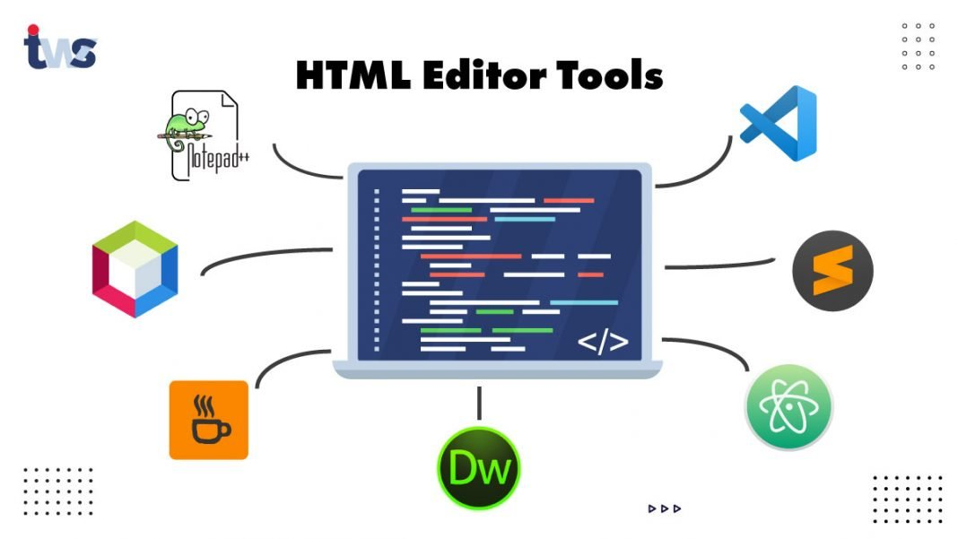

Those days are gone when web developers use to write the complete by themselves, now, with the evolving technologies, the demand for online editor tools is increasing. No doubt, you would use Notepad for website development, but make the development process more efficient and quick, there is a need for online HTML editor tools. The website developers probably choose the HTML editor tools due to the two most fascinating features: syntax highlighting and autocompletion. Having additional features in online HTML editor tools is its plus point. But, before starting with the topic of the HTML editor tools or IDE(Integrated Development Environment), let’s first discuss

**What is HTML?**

HTML is Hypertext Markup Language used to create the web pages of the websites. HTML is not a programming language; instead, it is used to develop a format for websites with paragraphs, Text, buttons, shapes, etc. So, now, let’s begin with the HTML Editors.

**What is HTML Editor Tools?**

HTML Editors are the tools that are used to create and edit the HTML code. Basically, HTML editor tools help you write the HTML code and allow the websites’ real-time preview. Some HTML Editors provide functionalities more than just writing the HTML codes. So, it varies from editor to editor. These HTML editor tools allow you to correct errors and analyze the code or website before it goes live. Some of the HTML editors are available online, or you can download them from the websites. There are several HTML editors available for web developers; all of these editors have their own unique functionalities and features.

**Which tool is used for HTML Coding?**

**What are the ten basic HTML tags?**

**Benefits of Using the HTML Editor Tools**

There are many benefits of using the HTML editor tools over simple Notepad for web development. Here are the benefits of using the HTML editors:

The use of HTML editors makes editing and development faster.

It helps the beginners to learn the HTML more quickly.

It makes the code more human-readable, as it includes the comments and other notes in coding.

Easy to develop a website and put online.

It provides a real-time preview of the HTML code.

It offers to autocomplete code features.

It facilities the platform for the easy learning of the HTML code.

**Read More:**[Top 10 Web Development Trends to Follow in 2020](https://www.tekkiwebsolutions.com/blog/latest-web-development-trends/)

**Best HTML Editor Tools for Web Developers**

Here is the list of some of the best HTML Editor Tools that are quite famous among web developers for HTML coding and real-time analysis of website development.

[Atom](https://atom.io/)

[Notepad++](https://notepad-plus-plus.org/)

[Sublime Text](https://www.sublimetext.com/)

[Adobe Dreamweaver CC](https://www.adobe.com/in/products/dreamweaver.html)

[Visual Studio Code](https://code.visualstudio.com/)

[CoffeeCup HTML Editor](https://www.coffeecup.com/html-editor/)

[Netbeans](https://netbeans.org/)

**Atom**



**Developed By** – GitHub  
**Initial Release** – February 26, 2014  
**Written in** – Electron, CoffeeScript, JavaScript, HTML, Less

Atom is a modern editing tool for Windows, Linux, and Mac. This HTML editor is full-featured, including the other programming languages for web development like JavaScript, Node.js, CSS. Atom is a free and open-source editor tool that allows the users to share the projects and allows collaboration using the GitHub repositories.

**Features of Atom HTML Editor**

* Atom is a free and open-source HTML editor.
* Atom supports the multiple panes to compare and write code side-by-side.
* Atom allows faster and smarter coding with a flexible autocompletion feature.
* Atom supports Teletype that helps the collaborate with other developers in real-time.
* Atom is a completely customizable HTML editor for website developers.
* Atom is a cross-platform editing tool.

**Notepad++**



**Developed By** – Don Ho  
**Initial Release** – November 25, 2003  
**Written in** – C++

Nodepad++ is a free HTML editing tool for Window users. It can also be used by Linux users, but with the help of Wine. Notepad++ is the first tool a developer often uses for the very first time. It is very simple and easy to learn and code on Nodepad++. Notepad++ handles several useful languages for WordPress developers that include HTML, CSS, PHP, and JavaScript.

**Features of Notepad++ Editor Tool**

* Notepad++ provides a simple, lightweight, and fast user interface.
* Notepad++ supports a multi-language coding environment.
* Nodepad++ is a free and open-source HTML editor.
* Developers can customize and personalize the features of Nodepad++.
* Nodepad++ offers the features for the addition and customizations of the plugins

**Sublime Text**



**Developed By** – Sublime HQ  
**Initial Release** – January 18, 2008  
**Written in** – C++, Python

The Sydney-based development company develops sublime Text HTML editor. It is a freemium HTML editor tool that you can use for free, but you need a license to access all features of Sublime Text. Sublime Text allows the community to add its own plugins, and it is an entirely customizable HTML editor. Sublime Text is compatible with all platforms like Windows, Linux, and Mac. Sublime Text is one of the most downloaded HTML editors for HTML coding in website development.

**Features of Sublime Text Editor Tool**

* Sublime Text is known for the functionality expansion as it supports Python APIs.
* Sublime Text allows real-time changes to the HTML code.
* Sublime Text also a cross-platform HTML editor.
* With Sublime Text, the developers can make simultaneous changes to the different code windows.
* Sublime Text automatically generates the class, method, and function definitions.

**Get Best Web Application Consulting by TWS**

With the advice of our team of experts, get a robust web app that will help you meet your business needs.

[Talk-to-experts](https://www.tekkiwebsolutions.com/talk-to-experts/)

**Adobe Dreamweaver CC**



**Developed By** – Adobe Inc.  
**Initial Release** – December 1997  
**Written in** – C++

Adobe Dreamweaver CC is a multifunctional web development tool featured with the HTML and CSS capabilities. Adobe Dreamweaver CC is a premium tool for Web Developers that fulfills both the front-end and back-end web development needs. Adobe Dreamweaver CC is one of the best HTML editors supporting both the textual and WYSIWYG methods for code editing.

**Features of Adobe Dreamweaver CC**

* Adobe Dreamweaver allows coding in any programming language.
* It supports both the textual and WYSIWYG coding methods for website development.
* Adobe Dreamweaver is known for its high-end performance and community support from Adobe Inc.
* Adobe Dreamweaver is integrated with the features of the Adobe software ecosystem.
* It allows the real-time preview of the end product while coding.
* It provides user access to creative cloud libraries.

**Visual Studio Code**



**Developed By** – Microsoft Corporation  
**Initial Release** – April 29, 2015  
**Written in** – TypeScript, JavaScript, CSS

Visual Studio Code is one of the popular HTML editor tools used for HTML code editing by the maximum number of web developers. Visual Studio Code is a free code editor with an immense number of features, including the smart autocompletion and syntax highlighter. For the easier deployment and development of the websites, it offers compatibility with Microsoft Azure. Microsoft Visual Studio Coe works with Python, HTML, and other common programming languages.

**Features of Visual Studio Code**

* Visual Studio Code allows the deployment with Microsoft Azure for easier deployment.
* It is cross-platform compatible with Windows, Linux, and Mac.
* It enhances the exposure to the advanced features with the IntelliSense integration.
* Visual Studio Code provides the customizations by adding extensions for plugins, debuggers, and other features.
* It allows the debugging feature for real-time results.
* Visual Studio offers the GitHub integration.



**Developed By** – CoffeeCup Software  
**Initial Release** – August 1996  
**Written in** – HTML, CSS

CoffeeCup is one of the best premium tools for HTML editing. It also offers a few days of free trial for a better developer experience of HTML coding. It is a WYSIWYG tool used for the easy editing and development of HTML websites. The premium version of CoffeeCup provides unlimited web developers’ complete features, ranging from FTP connections, HTML/CSS validation, code cleaning, etc.

**Features of CoffeeCup HTML editors**

* CoffeeCup is an HTML editor has better for customer support and easy to use.
* CoffeCup provides both free as well as a premium package for the developers.
* CoffeeCup offers customizable responsive themes for web development.
* It offers responsive tools and layouts for website development.
* It has large community support and regular upgrades.
* It allows integration with the HTML and CSS languages.

**Netbeans**



**Developed By** – Apache Software Foundation, Oracle Corporation  
**Initial Release** – 1997  
**Written in** – Java

Netbeans is also known as Apache Netbeans developed in Java programming language. Apache Netbeans helps web developers to robust web applications. Netbeans is not similar to most of the HTML editors as it provides the features of version control. Netbeans is a free and open-source HTML editor tools used by numerous giant companies for versatile [web development services](https://www.tekkiwebsolutions.com/web-development/).

**Features of Apache Netbeans**

* Netbeans is a free and open-source cross-platform HTML editor for web development.
* It helps to build powerful and robust web applications using HTML code.
* It allows you to code in multiple programming languages like HTML5, PHP, JavaScript, and other programming languages.
* It provides features like version control and autocompletes coding.
* Netbeans also offers smart and quick project management within the code editor.

Blog by TWS

.4 Knowledge of CSS tools and techniques

1. [**SCSS Compiler**](http://beautifytools.com/scss-compiler.php)

The SCSS compiler web app tool by BeautifyTools is an auto code generator for modern CSS workflow. So, if you are looking to utilize a great tool that can help you build and launch a site seamlessly, this is the ideal online CSS tool for you. Based on the structure and preformatted settings, the tool helps you convert raw SCSS into CSS while also enabling code minification and combining multiple files. So, now you can easily generate formatted CSS styles from SCSS code.

2. [**Keyframes.app**](https://keyframes.app/)

When [starting a blog](https://makeawebsitehub.com/how-to-start-a-blog/) or building a new website, simple tools are always charming because of their ease of usage and the fact that they get work done without any hassle. The Keyframes.app tool is one such tool that not only helps you generate CSS for all your projects but lets you do it the simple way. This is a web app that also offers a Chrome extension to help you easily create CSS animations. So, if you would be working with website builders to create powerful CSS, you must do it the easy way.

The Keyframes.app is a great tool that provides you a timeline view of how your work is progressing. So, you can easily see how your animations look, how they loop, and what are the prime areas of the sequence. This visual timeline and the ability to see the animations right in front of you lets you easily manipulate elements on the page.

So, now you can easily create basic or complex CSS just like it is with video-editing software. The tool also lets you create single or multi-layer box shadows through the use of some simple sliders. You can also create and save instant palettes by picking your chosen colors and converting between hex and RGB.

3. [**CSS Doodle**](https://css-doodle.com/)

This tool is a classic web component for drawing patterns with CSS. The tool is an SVG-enabler because it easily and quickly draws repeatable patterns. We talk of repeatable patterns because SVG graphics are all about reducing bandwidth by replacing patterns. Since the SVG graphic is also available in raw code format, CSS Doodle lets you utilize that to create further repeatable patterns.

The tool can be used on all major browsers without polyfills and is based on Shadow DOM v1 and Custom Elements v1. Based on these components, the CSS Doodle lets you generate a grid of divs by the rules (plain CSS) inside it. Users can further use CSS to manipulate the cells and craft patterns they want to.

4. [**CSS Filters**](https://www.cssfilters.co/)

We bet you have tried a filter or two on [social media platforms](https://thebluecube.com/how-to-choose-the-right-social-media-platform-for-your-business/) like Instagram and Facebook. They are so much in trend that a basic job expectation out of a designer is to at least be able to deliver kickass filters. Filters are the new cool reality that people of the Internet thoroughly love. So, if you are a programmer and are looking to create a filter of your own, the CSS Filters is a great tool for you. While creating such a tool from the beginning can be a huge challenge and overwhelming for a first-timer, using CSS Filters web app is going to provide the much-needed assistance.

The process is fairly simple with this web app; all you have to do is upload your cohen image and edit the settings using the tool. Now, simply export the code to start using your filters. And you will be done!

5. [**Gradient Hunt**](https://gradienthunt.com/)

If you are a programmer who has a knack for designing and colors, you very well know the amount of pain that it takes to design and match colors with precision. Pages that do not blend well are disastrous to look at and cause a horrible user experience. One such dicey designing element is the gradient. Since gradients make up for [excellent designing elements](https://www.forbes.com/sites/forbescommunicationscouncil/2019/08/12/dont-forget-about-these-15-elements-when-designing-your-retail-stores-layout/#73dae0f74ad3) and are now heavily used across the designing industry, there is a need to do it the right way.

Creating the right gradient might not be a cakewalk but with the right tool such as the Gradient Hunt, it is fairly easy to employ CSS3 code to create great-looking gradients. While the tool lets you do it easily, it also speeds up the process. It lets you choose the desired gradient from its curated collection and from there, you can further customize the gradients to suit your need and taste. Once done with the customization, you can simply copy the CSS code for your further use and apply the gradient as and when wanted.

6. [**PostCSS**](https://postcss.org/)

If you are looking to work with a tool that helps transform CSS with JavaScript, PostCSS is the tool. This tool lets you increase code readability by adding vendor prefixes to CSS rules using values from Can I Use. Its Autoprefixer assesses the popularity of the current browser and uses the data thereof to apply prefixes.

The tool comes with a collection of solutions that you can use for scenarios like grid generation and code linting. This free tool is a great one for enhancing developer skills.

7. [**CSS Blocks**](https://css-blocks.com/)

While CSS can be seamless to use and employ, it can sometimes really become a time-consuming factor towards your project completion. Built around modules, this CSS tool is a highly recommended one. Being a collection of CSS styles, CSS Blocks lets you choose the modules you need and from there on, you can easily export the modules and work on them based on how you want them to turn out.

The tool is known for its tiny runtime (~500b), dead code elimination, scoped styles, super-fast stylesheets, project-wide optimization, and the ability to showcase build time CSS errors. So, if you are a fan of designing super-efficient and fast CSS for your apps in less turnaround time, this is the right tool for you.

8. [**Scout app**](https://scout-app.io/)

If you are a developer looking to get started with dynamic CSS to be able to work in Windows, Mac, and Linux environments, Scout App is a great tool to utilize. By employing a Sass/Compass GUI, one can easily work with dynamic CSS. This tool lets you organize everything in one place: CSS files, templates, boilerplates, etc. You won’t have to worry about spending time learning terminal commands. So, Scout App is your best way to process Sass and SCSS to CSS and is also designed with a powerful translation engine allowing it to be multilingual.

9. [**Sierra Library**](https://sierra-library.github.io/)

Touted to be the smallest and lightest SCSS library, Sierra Library is an open-source, lightweight, and customizable tool. It is quick to install and download. You can also customize the library’s theme settings, including fonts, margins, paddings and/or colors. You can also create your custom-settings file. The tool lets you take care of elements such as Badges, Buttons, Fonts, Forms, Loaders, Notifications, Pagination, Tables, Tabs, Tags, and Utilities among others.

10. [**CSS Menu Maker**](http://cssmenumaker.com/)

Well, glamorous webapps for CSS also exist and if you are drawn towards them, CSS Menu Maker is the tool or you. The web app lets you browse through different styles of navigation menus to help you with dropdowns, fly-ins, and other pure CSS based options. So, if your work or current projects need you to work around menus, the tool lets you build & download HTML, CSS, & jQuery menus for desktop & mobile websites.

With CSS Menu maker, you get 65+ menu themes to choose from while creating custom, cross-browser compatible CSS menus. You don’t need to know complicated code in order to be able to create awesome menus. The tool provides the source code for all our CSS menus. Hence, you can easily customize and integrate as per your requirements.

.5 Graphics -Gimp/Photoshop/Paint tools and techniques

Hardware

1. Pen and paper

The fastest, cheapest, and easiest way to transfer design ideas from your head to the real world is to use good old pen and paper. Besides giving you a chance to stay off the grid for a few moments, analog sketches also serve somewhat like the sacred link between the great graphic artists of the past and the new tech-enabled designers of today.

More importantly, using pen and paper allows you to “intuitively draw” the design concepts in your mind, and quickly discover problems and solutions as your sketches take rudimentary shape. Research even shows that taking notes, doodling, and writing by hand enhances focus, creativity, and openness to learning.

If you’re passionate about this creative method, then go all the way by investing in iconic pencil (Rotring, Faber-Castell, etc) and notebook brands (Moleskine, Field Notes, etc.).

2. Computer

For digital creatives, this is the ultimate tool that performs all the heavy lifting in the profession. If you can afford the best and most powerful —  the iMac Pro or the Surface Studio, for example — do so by all means.

The iMac sustains a loyal following of hardcore designers largely by including coolness in its core features. But branding is hardly the whole story. The latest iMac Pro is considered overkill by any standard: having a 27-inch 5K Retina Display, 32-GB memory, a 16-GB graphics card, and an 18-core processor for the high-end variant.

Meanwhile, Microsoft Surface Studio is a worthy rival capable of shifting the balance by giving PC loyalists major bragging rights for (finally) owning something remarkably sleek, powerful, and agile — all in one surprisingly elegant package. You can use it in its traditional desktop mode with a stylishly thin 28-inch PixelSense display; or transform it into a large, touch-screen tablet — an instant digital drawing board — for fast and intuitive designing, especially with the responsive Surface Pen thankfully thrown in to punctuate the statement.

However, if just salivating over these dream workhorses makes your wallet groan, there’s no shame in making do with what the rest of humanity uses. Any decent computer that can adequately handle graphics software and reliably connect to the cloud can sustain your life as a modern-day graphics designer.

3. Stylus and graphics tablet

Creatives who have a dominant tech gene in their DNA will likely prefer the digital equivalent of pencil and paper for their sketching and doodling tasks. When it comes down to it, even their more traditional cousins who sleep with analog pens in hand sometimes seek the souped-up functionalities of an electronic pencil and paper.

So if you find yourself craving a hybrid tool that allows you to continue making hand drawings like a classical artist but using the tools of a tech geek, don’t be embarrassed nor feel that you are betraying the trade. Instead, check out state-of-the-art tools such as the industry standard Wacom tablet/Pro Pen and the versatile iPad Pro in tandem with the Apple Pencil.

Either could simulate the authentic feel of drawing sketches or creating wireframes, in addition to giving you some wicked capabilities (instant color, filters, eraser, storage, superb editing, etc.) that you just can’t execute using ordinary pen and paper.

 4. Smartphone

This gadget helps us connect with peers, customers, and the world wide web. It also hosts your favorite apps — including really handy on-the-go drawing and image-editing tools. Plus, the smartphone doubles as a decent camera for unexpected moments when you need one and your sturdy Canon or Nikon is snug as a bug inside its case back at home.

For web designers, a smartphone on hand is also the easiest way to find out whether a specific web page design properly renders on small screens. As can be expected, graphic designers don’t agree on which smartphone model is the best for their profession, but you’ll find loud voices supporting either Samsung’s flagship Galaxy S phones as well as Apple’s latest iPhone iteration.

5. Camera

For creatives who need to take, edit, and manage hyper-precise photos and videos, nothing but a decent DSLR (Digital Single Lens Reflex) will do. And when DSLRs are concerned, two iconic brands — the Canon EOS and Nikon D-series — lead the pack. Both are pricey of course and if budget is a big issue, there are more affordable alternatives in the market that are also capable of capturing pixel-perfect shots.

6. Color space reference

Never settle for counterfeit colors. For the uninitiated, a shade of color that resembles blue might as well be blue, but for design professionals, color accuracy and rendering precision matter big time.

If your work has a significant print component, having a color space reference is a must. The Pantone Matching System is recognized as the industry standard and you can invest in the Formula Guide for nearly 2000 spot colors, the basic Color Bridge Set, or mini Color Swatches depending on your client portfolio and design focus.

7. Monitor calibrator

Another way to control runaway colors is to use monitor calibrators. These devices ensure that the colors you see on your screen will be exactly the same ones that come out in printed outputs such as posters, brochures, and magazines.

X-Rite and Datacolor are the leading monitor calibrator brands, with ColorMunki Smile and Spyder5EXPRESS as their respective entry-level models.

8.  Storage

While cloud storage is already available, many graphic designers still opt to have backup physical storage devices close at hand. Because entire libraries of images and videos can easily eat up storage space, you may want to invest in high-capacity, portable models such My PassPort series from Western Digital and MiniStation Extreme NFC from Buffalo.

Choose models with at least a terabyte of storage. Designers who have larger budgets and prefer super-fast plug-and-play processing will likely go for solid state drives (SSD). If you belong to this group, then Samsung’s T3 SSD — which comes with 1-terabyte of storage space — is a good option.

Software

9. Graphic design applications

This is the largest and arguably most important part of a digital artist’s tool stack. Whether installed to run from a desktop computer or offered as a cloud-based service, these [software applications](https://www.goskills.com/Design/Articles/Illustrator-vs-Photoshop-vs-InDesign) enable graphic designers to create, edit, store, and manage their creative output: photos, images, videos, presentations, brochures, and other visual formats.

The Adobe Creative Cloud sets the standard for this tool type, providing a full suite of applications for creating and manipulating raster graphics ([Photoshop](https://www.goskills.com/Course/Photoshop-Basic)), vector images ([Illustrator](https://www.goskills.com/Course/Illustrator-Basic)), videos (After Effects, Premiere Pro), and different [desktop publishing](https://www.goskills.com/Course/Microsoft-Publisher) formats such as posters, magazines, brochures, and ebooks (InDesign).

Paid alternatives to specific applications in Adobe’s subscription service include Serif’s Affinity Designer (vector) and Affinity Photo (raster), CorelDRAW (vector), and the macOS-exclusive Sketch (vector).

Free [tools with similar capabilities](https://www.pixpa.com/blog/graphic-design-software) include GIMP (GNU Image Manipulation Program) for authoring and manipulating raster images and Inkscape for creating and editing vector graphics.

10. Online graphic design services

With the advance of cloud computing technology, several companies started offering web-based graphic design services that primarily target general consumers (i.e., non-professional/occasional designers).

Foremost among these providers is [Canva](http://www.canva.com/), a simple drag-and-drop online tool that allows anyone to quickly author, edit, and share images. The website is perfect for non-designers as well as hardcore creatives occasionally looking for a quick way to create images for various purposes (e.g., blog illustrations, social media posts, etc.) and in various formats (e.g., infographics, presentations, header images, etc.). Snappa offers a similar service and interface, or you might consider [Design Wizard](https://www.designwizard.com/) to quickly create both images and videos.

Another option is Venngage, a template-based design tool that lets anyone create professional content like [business presentations](https://venngage.com/templates/presentations/business), white papers, reports, marketing materials and more. The tool provides users with access to over 10,000 icons, thousands of stock photos, and tons of customizable charts and graphs.

Additionally, you can use Pixlr for simple photo-editing online; Invision for collaborative screen prototyping; and Artboard Studio for quickly creating product mockups.

11. Graphics repositories

Online libraries of images such as Shutterstock, Behance, and [Depositphotos](https://depositphotos.com/) are great places to visit and get design ideas from. Some of these repositories (such as Pixabay, Pixelify, and Unsplash) even provide free downloadable images you can legally use in your projects.

12. Cloud storage

You have your hard drive and portable storage. That's well and good, but you still need a space in the cloud to store, synchronize, and manage your design assets, projects, and output. Among other things, cloud storage makes it easier to share and collaborate on design documents, besides being accessible anytime and anywhere — which is hardly the case when you forgot to bring your portable physical drive to work.

Creating a profile or an account for some online services can entitle you to limited cloud storage space. This is the case when you have accounts for Google (Google Drive), Microsoft (OneDrive), and Adobe (Document Cloud). Cloud storage providers such as pCloud, Dropbox, and MediaFire also give free storage space. However, free options generally entitle you to only 1GB to 15GB of free space so you might want to check out subscription fees at these services if you need larger storage.

Instruction, insight, and inspiration

13. Portfolio

Even a humble graphic designer needs to have some form of conceit to show off her creations. Portfolio website services such as Wix, SquareSpace, and Adobe Portfolio (Behance) help designers consolidate and curate the creative efforts they are proud of, and communicate their credentials to prospective employers, clients, and peers. Heck, what better thing to do with artwork than to share it with the world.

If you're new to the world of graphic design and want to build out your portfolio, sites like [Createxplore](https://createxplore.com/) can help you get connected with charities and small businesses.

14. Training

The field of design is in constant flux as technology, aesthetic standards, and markets shift. This means designers always need to improve their knowledge of the craft and develop new skills that will enable them to produce creative outputs that will remain relevant and meaningful to their intended audiences. Learning portals like [GoSkills](https://www.goskills.com/Design/Courses) are great websites to learn new trends and techniques in graphic design.

15. Resource sites

Creatives are arguably the subset of professionals most in need of inspiration. Besides getting that from their immediate environment (hopefully), these professionals can visit design-focused websites that publish advice, tips, and doses of inspirational materials that can help motivate stressed out or low-energy designers. Behance, Abduzeedo, Uncrate, and Google Arts & Culture are some of the best places in cyberspace that can ignite that creative spark in you.

16. Your own workspace/creative nook

Designers differ when it comes to how an inspiring workstation should look like. Some prefer extremely minimalist themes while others clutter their spaces with toys, nostalgic memorabilia, and other eye candies. Depending on your aesthetic sensibilities, transform your workspaces so they can become an integral and proactive component of your workflow. Consider lighting, color schemes, access to windows, and ergonomics when designing and setting up your own creative nook.

.6 SVG-Inkscape/illustrator tools and techniques

**Inkscape Interface**

The **Inkscape** interface is constituted of elements designed to make work simple, harmonious and contextual.  It is composed principally of a single window in which one creates and manipulates drawings.  Within the window, lie particular components which this chapter will identify, enabling readers to easily navigate the software.

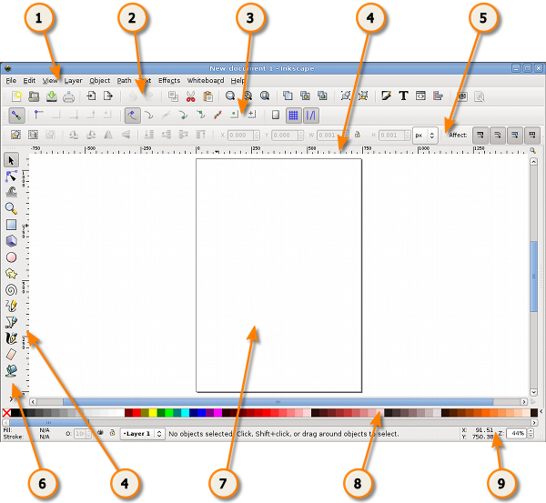

We may divide the window into nine major areas:

1. the **Menu** (at the top of the window)
2. the **Commands Bar**
3. the **Snap Controls Bar**
4. the **Rulers**, **Guides** and **Grids**
5. the **Tool Controls Bar** (also called just **Controls Bar**)
6. the **Toolbox**
7. the **Canvas**
8. the **Color Palette**
9. the **Status Bar**

The many toolbars that are available in Inkscape can take up a lot of visual space on your screen. To reduce the toolbar size. Use *File > Inkscape Preferences...* then select the **Interface** option.  Here you can individually set the Commands Bar Icon Size, the Tool Controls Bar Icon Size and the Main toolbar Icon Size.

**The Menu**



As in most **GTK** applications, the Inkscape Menu contains the essential functions of any program, those which concern the application itself: New, Open, Save, Export, Quit, etc.  The Menu also consists of functions related to drawing.

**The Commands Bar**



The **Commands Bar** is located at the top of the workspace directly underneath the Menu.  It contains icons which are shortcuts to commands otherwise accessible from the menus or shortcut keys. It also houses other controls for manipulating the document and drawing objects.  For example, from the Commands Bar one can open a new or existing document, print, import an image, undo previous commands, zoom, open the dialog to adjust document properties, etc.  Hovering the mouse cursor over each icon will display its functions through **tooltips**.

There may be an arrow on the right side of the Commands Bar pointing down. Clicking this will reveal any command shortcuts that unable to fit on the bar due to monitor size or resolution settings.

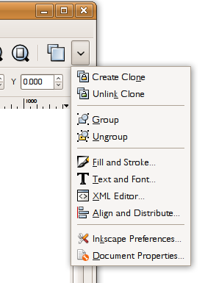

**The Toolbox and Tool Controls Bar**



The **Toolbox**, consisting of vertically aligned buttons located on the left of the window, is Inkscape's main editing control.  It contains the basic set of drawing utilities, particularly those for creating and editing **shapes**.  There are controls for geometric shapes as well as **free-form** shapes and lines, text, and **fills** (colors and **gradients**).

Located directly under the Commands Bar is the **Tool Controls Bar**.

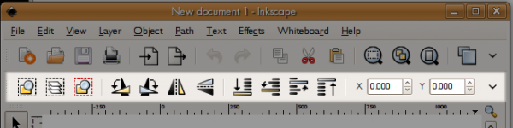

Selecting a tool in the Toolbox changes the Tool Controls Bar to show particular options associated with that tool.  Depending on context, some of these options affect a selected **object** while some take effect only when drawing a new object; others can affect either existing or new objects.

**The Canvas**



The **Canvas** is the main workspace. It is the most central and important part of the interface since a user creates and views drawings there. It occupies the middle of the window and is represented as a blank "page" surrounded by open space.  By default, rulers measuring **pixels** (the standard **SVG** unit) run above and to the left of the Canvas, but one can adjust these defaults (*ruler visibility* and *unit*) in Document Properties.

While the "page" defines the boundaries of a document intended for certain media (print, export, etc.), the page boundaries do not limit the actual SVG image.  In fact, users may make the page border and shadow invisible in the Document Properties.  Some artists prefer to use a particular page boundary and use the white space as "scratch paper"; others prefer not to be limited by page boundaries.

**Rulers**

The **Rulers** are graduated lines placed on top and left of the canvas. The first is called "horizontal" and the second "vertical". Graduations represent distances and are expressed in units that can be set in the *Units option* of the *Page tab* of the *File* > *Document Properties* menu command*.*

When the mouse is over the canvas, two triangles appear in the rulers to show its X and Y coordinates, relative to the page's bottom left corner. Those coordinates are also displayed in the Status Bar (at the bottom of the document window) on the right, near the Zoom Control.

**Note :** In SVG, coordinates begin at the bottom left of the document like in **Cartesian geometry**.

**Ctrl** + **R** is a quick way to hide or display the Rulers. One can also do that with the *View*>*Show/Hide*>*Rulers* menu command.



**Guides**

**Guides** are user-defined 'magnetic' lines. Using Guides makes object alignment easy even with the mouse. To use Guides, click and drag from the Rulers to the point where the Guide is to be inserted and release. Clicking and dragging from the horizontal Ruler produces a horizontal Guide. Clicking and dragging from the vertical Ruler produces a vertical Guide.

**How to use**

**Moving Guides**

When the Selector Tool **F1** is active, passing the mouse over a Guide will change its color to red. Then, click and drag the Guide where you want.

**Deleting guides**

To delete a guide, just drag it to the appropriate Ruler with the Selector Tool **F1**

**Guide Visibility**

To make Guides invisible, without deleting them, select *View* > *Guides* from the Menu Bar. The keyboard shortcut for toggling Guide visibility is **Shift** ***|*** (hold shift and press the pipe - **|** - key, which is usually paired with the backslash key.)

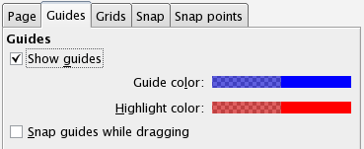  
  
  
*File* > *Document properties* lets you define if Guides should be displayed by default, and the color of both the Guide itself and the highlight when the mouse is passing over.

Guides are also often used with snapping making it much easier to place objects on the canvas, especially for precise or technical drawings. In this case just check the *Snap guides while dragging* checkbox.

**Grids**

Instead of using lots of Guides, it can be useful to activate **Grids**. Do this with the *View* > *Grid* menu or press # (**Shift** + **3** ).

Grids are of 2 types : rectangular and **axonometric**. They can be defined in the window from the   *File* > *Document properties* menu. Most commonly used is the rectangular Grid which is made of vertical and horizontal lines.

Axonometric Grids allow the user to define any kind of angled Grid which can be interesting for technical or architectural drawings.

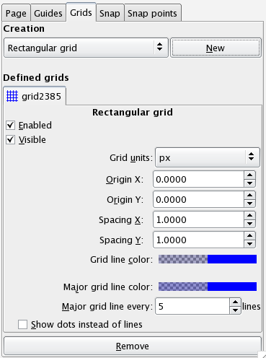

Here is an example of a standard axonometric grid and a rectangular grid.

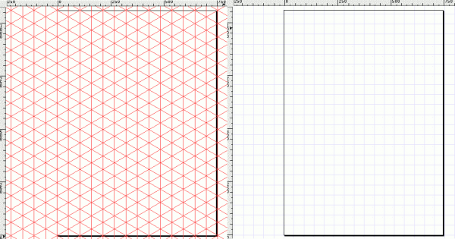

**How to Use**

Use the drop down list in the *"*Document Properties" dialog to select which type of grid to use then click the "New" button. A new tab is created under "Defined grids" (several grids can be defined for a single document). Then define the units you would like to use and both the Origin point and the distance (Spacing) between two lines of the Grid.  When using Axonometric Grids there is also the option to define the angle of two grid lines.

**Enabled**

Tick the box to use this grid in the current document. Can be left 'on' in invisible grids to maintain snap to grid controls.

**Visible**

Tick to display the grid on the canvas. Switch off to make the grid invisible.  This option sets the default value for each grid so that even if Visible is ticked here, it is still possible to toggle View Grid on and off via the menu or by hitting the # key. If the *View > Grid* menu is unchecked, the grid won't be visible on the canvas even if "Visible" is checked here.

**Grid Units**

Many commonly used units are available from mm, to feet and px. Choose the one that best suits your needs. If no special needs, keep the default px.

**Origin X and Y**

Defines the beginning point of the Grid.  Usually set to '0' (zero) it can be useful to change these if an offset is needed, especially to define margins from the edge of the Canvas.

**Spacing X and Y**

Defines the space between two lines of the Grid. These spaces can be different for horizontal and vertical lines so that the Grid pattern can be set to any kind of rectangle.

**Angle X and Z**

Only available for Axonometric Grids. Defines the the angles for the Grid Lines on the X and Z axes.

**Grid line color**

The default color for the Grid is blue, but this can be changed here. There are two kinds of line. The most often used is the Grid line, but when the grid spacing is short and many lines are displayed the Major Grid line helps to evaluate distances. In this case a different color can be defined for each type of line and the frequency of the Major Grid line can be set (usually 5 or 10).

**Show dots instead of lines**

Available on Rectangular Grid Only. Since lines can overload the screen, it can be uneasy working with Drawing Tools when the grid is visible. This option toggles between lines and dots for displaying the grid, creating a less overloaded screen.

**Snap Controls Bar**



The **Snap Controls Bar** gives easy access to object snapping enabling you to quickly turn snapping on when required and the off when finished.  It also allows customisation of the snapping feature letting you select what can be snapped and what objects can snap to.

**Color Palette**



The **Color Palette** is a quick way to apply color to shapes. It is displayed at the bottom of the Canvas, or can be opened in a window by selecting *View* > *Swatches* ( **Shift** + **Ctrl** + **W** )

**How to Use**

To find the color you like, just scroll along the swatch line and choose. You can change the color palette with another preset by clicking the triangle at the right of the bar and choosing one.

To apply a color to a shapes "Fill color", just click on a color after selecting one or more shapes.

To apply color to the "Stroke", press **Shift** while clicking and it's done.

**Status Bar**



Status Bar is the bottom-most area of the Inkscape interface. It includes (from left to right) :

* Color indicator for the object
* Quick layer selector
* Help message area
* Mouse Coordinate indicator
* and finally a Zoom Factor in which one can write the exact zoom factor they want to use.
* **INTRODUCTION**
* [**ABOUT INKSCAPE**](https://archive.flossmanuals.net/inkscape/introduction/index.html)
* [**ABOUT SVG**](https://archive.flossmanuals.net/inkscape/introduction/about-svg.html)
* [**THE INKSCAPE INTERFACE**](https://archive.flossmanuals.net/inkscape/introduction/the-inkscape-interface.html)
* [**WORKING WITH FILES**](https://archive.flossmanuals.net/inkscape/introduction/working-with-files.html)
* **TOOLBOX**
* [**SELECT TOOL**](https://archive.flossmanuals.net/inkscape/toolbox/select-tool.html)
* [**NODE TOOL**](https://archive.flossmanuals.net/inkscape/toolbox/node-tool.html)
* [**TWEAK TOOL**](https://archive.flossmanuals.net/inkscape/toolbox/tweak-tool.html)
* [**ZOOM TOOL**](https://archive.flossmanuals.net/inkscape/toolbox/zoom-tool.html)
* [**RECTANGLE TOOL**](https://archive.flossmanuals.net/inkscape/toolbox/rectangle-tool.html)
* [**3D BOX TOOL**](https://archive.flossmanuals.net/inkscape/toolbox/3d-box-tool.html)
* [**ELLIPSE TOOL**](https://archive.flossmanuals.net/inkscape/toolbox/ellipse-tool.html)
* [**STAR TOOL**](https://archive.flossmanuals.net/inkscape/toolbox/star-tool.html)
* [**SPIRAL TOOL**](https://archive.flossmanuals.net/inkscape/toolbox/spiral-tool.html)
* [**PENCIL TOOL**](https://archive.flossmanuals.net/inkscape/toolbox/pencil-tool.html)
* [**PEN TOOL**](https://archive.flossmanuals.net/inkscape/toolbox/pen-tool.html)
* [**CALLIGRAPHY TOOL**](https://archive.flossmanuals.net/inkscape/toolbox/calligraphy-tool.html)
* [**BUCKET FILL TOOL**](https://archive.flossmanuals.net/inkscape/toolbox/bucket-fill-tool.html)
* [**TEXT TOOL**](https://archive.flossmanuals.net/inkscape/toolbox/text-tool.html)
* [**CONNECTOR TOOL**](https://archive.flossmanuals.net/inkscape/toolbox/connector-tool.html)
* [**GRADIENT TOOL**](https://archive.flossmanuals.net/inkscape/toolbox/gradient-tool.html)
* [**DROPPER TOOL**](https://archive.flossmanuals.net/inkscape/toolbox/dropper-tool.html)
* **PATHS**
* [**MODIFY PATH**](https://archive.flossmanuals.net/inkscape/paths/modify-path.html)
* **TEXT**
* [**STYLING TEXT**](https://archive.flossmanuals.net/inkscape/text/styling-text.html)
* [**TEXT EFFECTS**](https://archive.flossmanuals.net/inkscape/text/text-effects.html)
* [**TEXT AND PATHS**](https://archive.flossmanuals.net/inkscape/text/text-and-paths.html)
* **MULTIPLE OBJECT OPERATIONS**
* [**COPY, CLONE, & DUPLICATE**](https://archive.flossmanuals.net/inkscape/multiple-object-operations/copy-clone-duplicate.html)
* [**CLIP AND MASK**](https://archive.flossmanuals.net/inkscape/multiple-object-operations/clip-and-mask.html)
* **POSITIONING OBJECTS**
* [**INTRODUCTION**](https://archive.flossmanuals.net/inkscape/positioning-objects/introduction.html)
* [**ALIGN AND DISTRIBUTE**](https://archive.flossmanuals.net/inkscape/positioning-objects/align-and-distribute.html)
* **ORGANISING OBJECTS**
* [**LAYERS**](https://archive.flossmanuals.net/inkscape/organising-objects/layers.html)
* [**GROUPING**](https://archive.flossmanuals.net/inkscape/organising-objects/grouping.html)
* **STYLING OBJECTS**
* [**INTRODUCTION**](https://archive.flossmanuals.net/inkscape/styling-objects/introduction.html)
* [**FILL AND STROKE**](https://archive.flossmanuals.net/inkscape/styling-objects/fill-and-stroke.html)
* [**STROKE STYLE**](https://archive.flossmanuals.net/inkscape/styling-objects/stroke-style.html)
* [**COLOR PALETTE**](https://archive.flossmanuals.net/inkscape/styling-objects/color-palette.html)
* **LIVE PATH EFFECTS**
* [**INTRODUCTION**](https://archive.flossmanuals.net/inkscape/live-path-effects/introduction.html)
* [**GEARS**](https://archive.flossmanuals.net/inkscape/live-path-effects/gears.html)
* [**PATTERN ALONG PATH**](https://archive.flossmanuals.net/inkscape/live-path-effects/pattern-along-path.html)
* [**KNOT**](https://archive.flossmanuals.net/inkscape/live-path-effects/knot.html)
* **SVG FILTERS**
* [**INTRODUCTION**](https://archive.flossmanuals.net/inkscape/svg-filters/introduction.html)
* **ADVANCED**
* [**COLOR MANAGEMENT**](https://archive.flossmanuals.net/inkscape/advanced/color-management.html)
* [**GENERATE TEMPLATE**](https://archive.flossmanuals.net/inkscape/advanced/generate-template.html)
* **TUTORIALS**
* [**INSTALLING ON WINDOWS**](https://archive.flossmanuals.net/inkscape/tutorials/installing-on-windows.html)
* [**CREATING ICONS**](https://archive.flossmanuals.net/inkscape/tutorials/creating-icons.html)
* **APPENDICES**
* [**CREDITS**](https://archive.flossmanuals.net/inkscape/appendices/credits.html)

.7 Sound- Audacity/Abelton

What is Audacity?

[Audacity](https://www.audacityteam.org/) is a free-to-use, open-source digital audio editor and recorder software designed for macOS, Windows, GNU/Linux, and other operating systems like Unix-like.

As of January 3rd, 2022, Audacity has become the most popular download from [FossHub](https://www.fosshub.com/Audacity.html" \t "_blank), with over 111 million downloads. And this number is only as of March 2015. With previous downloads added, the number goes up to approximately 200 million downloads.

There must be a reason a lot of people download and use this software. So, what features does Audacity have?

Features of Audacity

Apart from recording audio from multiple sources, you can use this digital audio editing software to post-processing all audio types, such as adding normalization and fading in/out effects or trimming.

**Other outstanding features of Audacity include:**

* Editing multiple audio formats such as MP3, MP2, AIFF, FLAC, WAV
* Changing the speed or pitch
* Ability to record live sound and audio playback on PC
* Duplicating, cutting, blending, and grafting different sound documents together
* Scrubbing (for Version 2.1.1 and later)
* Timer Record that enables users to schedule when a recording begins and ends
* Noise reduction
* Voice reduction and isolation to create isolated vocal tracks or karaoke tracks
* Ability to save and load user presets for effect settings
* Converting cassette tapes and records into digital tracks

What Can You Do with Audacity?

In terms of what you can do, Audacity offers a wide range of uses. You can create interviews, work on voiceovers, edit music, record podcasts, remove/edit any kind of voice or sound. It’s even possible to record and mix an entire album.  You can record voiceovers, autotune records, remove background noise, delete awkward silences or the parts you made a misspelling, and so on.

*Speaking of podcasts, if you are in the startup business, we recommend reading*[*13 Best Podcasts About Startups and Growth*](https://userguiding.com/blog/best-podcast-suggestions-about-startups-growth/)*.*

If you are new to Audacity, there are plenty of **Audacity tutorials** and resources available on the internet. We will mention some of the best ones later in this article.

So, what do you need to start using Audacity?

* Set up the software.
* A computer that supports Audacity software
* It’s not necessary, but the sound quality will be better with an external microphone. Headphones or earbuds with mics will also do based on how much voice quality you need.

And that’s all you need. So, do you have questions in your mind like “is Audacity hard to use? Is Audacity good for beginners?” The answer is: Audacity is very easy to use, and it is an excellent piece of software for beginners who want to record and edit voices and records like a pro.

Before we dive into how to use Audacity step by step, let’s see why you should use it.

Why Should You Use Audacity?

One of the best things about Audacity is that it allows working on complex audio projects longer than an hour. It is a consistent and stable software to preserve even under high disk usage and processor loads.

Working with Audacity is incredibly simple. It supports the different recognizable audio files such as **MP3** or **WAV**. You can directly import an existing audio file into the software.

Audacity lets you record in either 16-bit or 24-bit audio. The digital recording and editing software can smoothly convert and combine any sounds you drag and drop into the interface. It does that regardless of the format.



As for **editing**, users can cut, copy, paste, duplicate, trim audio or arrange multiple clips on the same track. Moreover, the envelope tool enables adding custom fades as well.

Speaking of **effects**, Audacity provides a large pack of basic effects right out of the box. There are simple Bass and Treble adjustments as well as high- and low-pass filters.

In short, if you are looking for an easy-to-use but high in capabilities software to record, edit, and mix audio clips, Audacity will be your go-to software.

*If you plan to use Audacity for your video tutorials, you should also see our*[*Guide to Creating Training Videos and Video Tutorials*](https://userguiding.com/blog/training-video-tutorials/)*.*

How to Use Audacity Step-by-Step

Audacity is a very straightforward audio software, so it’s easier to grasp the basics. Follow the steps below to learn how to use Audacity on Windows and how to use Audacity on Mac likewise.

How do you use Audacity step by step? Here’s how:

Step 1: Find & import the file you want to edit

Start by importing an audio file into Audacity. It supports common audio formats such as MP3, WAV, and AIFF. You need to install the optional [FFmpeg library](https://manual.audacityteam.org/man/faq_installation_and_plug_ins.html" \l "installffmpeg" \t "_blank) for a more extensive range of formats. Note that Audacity cannot import copy-protected music files.

To import an audio file, select**File > Import > Audio**.

For a quicker method, just drag and drop the files into the Audacity window.

Step 2: Check the waveform

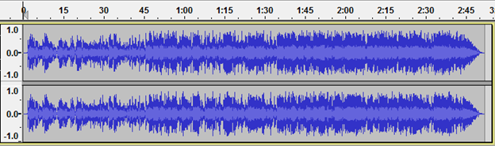

Stereo waveforms in Audacity look like the image above. The audio is louder where the waves reach or closer to the top or bottom (vice versa.) The ruler indicates the length of the audio clip.

Check the waveforms to detect any [DC offset](https://en.wikipedia.org/wiki/DC_bias), which refers to a waveform that is not centered on the horizontal line at 0.0 amplitude. Most of the time, it is caused by recording with a faulty audio interface.

Select the clip, click on Normalize to remove the DC offset.

Listen to the audio by clicking on the play ▶️ and stop ⏹️ , or you can use the Space button as a shortcut to play and pause.

Step 3: Select and change the range of audio you want

To change any part of your audio clip, first, select the part you want to change. You can cut, copy, paste, and duplicate, just like editing a selected text.



The image above shows Audacity’s toolbar. So, how to zoom in Audacity? You can use the magnifiers to zoom in and out or  **View** > **Zoom** >**Zoom In** (or Ctrl + 1) and**View** > **Zoom** > **Zoom Out** (or Ctrl + 3).

Zooming in and out helps you make the most of the window space. Once you select a specific range of audio and click on play, you can listen to only the selected part.

**How to split audio in Audacity?**

1. Click on the selection tool, and select the split point in the clip.
2. Then select Edit and Clip Boundaries.
3. Select Split.
4. Or use the keyboard shortcuts Command + I on the Mac or Control + I on the PC to Split the audio.

If you make any mistakes, you can always click on **Edit > Undo**.

**How to trim audio in Audacity?**

Make sure to stop the audio by pressing Space if it’s still playing. Select the excerpt you want to delete. Click on **Edit > Remove Special > Trim Audio**. You can undo or redo if you make mistakes. After you delete the selected parts or trim the audio, the remaining excerpt might be away from the track’s beginning. Use **Tracks > Align Tracks > Start to Zero** to align it.

However, this is not necessary when exporting the file because Audacity ignores the white space while exporting.

Step 4: Make the last second fade out

**How to use Audacity fade out?**

* Click the *Skip to End* button to go to the end of the track.
* Zoom in to see the last one or two seconds just before the end.
* Click the waveform one second before the end.
* **Select > Region > Cursor to Track End**.
* Then, select **Effect > Fade Out** to make the audio smoothly fade out.

Step 5: Export the final version

Mind that when you select **File > Save Project > Save Project**, you are just saving the file as an Audacity project, and it can only be opened with Audacity. If you want to open your file in other applications such as Windows Media Player or Apple Music/iTunes, you need to export it.

Before you export the file, go to the *Import/Export Preferences*and see under *When exporting tracks to an audio file,*thenuncheck “**Show Metadata Editor prior to export step**.”

This Metadata Editor adds extra information about the voice or music into the file. You can always check it back if necessary.

**To Export a WAV file;**

* Select File > Export > Export Audio
* Change the file name
* Choose a location to save
* Select the “WAV (Microsoft) signed 16-bit PCM” from the bottom of the save dialog menu labeled “Format.”
* Click Save.

**To Export an MP3 file;**

* Choose “MP3  files” in the save dialog menu.
* Click the Options menu to set the bit rate and other options.

Step 6: Test your audio

Finally, you should test the audio file you saved. Open the exported file (not the Audacity project file or the AUP in short) in Windows Media Player or Apple Music/iTunes etc.

Don’t forget to save the changes in your Audacity project file if you want to make additional changes to the final version in the future.

Getting Started with the Basics of Audacity

How to increase volume in Audacity

* Select a range of tracks or the whole track depending on the part you want to amplify.
* Click on Effect > Amplify.
* A window will open. Set the New Peak Amplitude to -3.0 dB (ideally.)
* Make sure “Allow Clipping” is unchecked to prevent peaking. Then, click OK.

How to use noise reduction in Audacity

* Select a part of the waveform containing only noise.
* Go to the Effects menu and select the Noise Removal tab.
* Click on “**Get Noise Profile**.”
* Select and highlight the region you want to remove the background noise.
* Go to **Effects > Noise Removal**.
* Adjust the settings and click OK.

How to move Audio in Audacity

* Select the Timeshift tool.
* Select a track by clicking on the waveform.
* Simply drag it left or right and move it anywhere on the timeline.

How to use Audacity to record

* Make sure your microphone is plugged in.
* Check your microphone and Audacity settings by going Edit > Preferences. Recommended settings:
  + Audio I/O >> Recording Channels [Mono (1)] >> [OK]
  + Quality >> Default Sample Rate [22050 Hz] >> [OK]
* Click on the red Record button to start recording.
* Click on the yellow Stop button to stop recording.
* Export by clicking on File > Export as.

How to slow down audio in Audacity

* Select the area you want to slow down. Or go to Edit > Select All to select the entire track.
* Click on Effect > Change Tempo.
* Drag the slider left to set up how much you want to slow the track down.
* Click OK.

How to use Autotune in Audacity

You need to install the GSnap plugin, which is completely free, to autotune in Audacity. This plugin can be used in Windows, macOS, and Linux devices. To install the GSnap plugin, copy its file into Audacity’s  “Plug-Ins” folder. Then, enable the plugin in Audacity.

* Go to Effect > Add/Remove Plug-ins and add the GSnap plugin.
* Then, GSnap will be listed on the Effect tab.
* Click on it to Autotune selected audio.

How to Bass Boost in Audacity

* Select audio (entire track or a part of it.)
* Go to Effects > Bass and Treble.
* Keep the treble at zero and set up the bass levels as you like.
* Click OK when finished.

**Ableton Recording**

**17. Recording New Clips**

This chapter is about recording new clips from audio and MIDI input signals. Note that this is a different kind of recording than the capturing of Session clips into the Arrangement ([see 7.5](https://www.ableton.com/en/manual/session-view/#7-5-recording-sessions-into-the-arrangement)).

For successful audio recording, please make sure the audio preferences are set up properly. For more on this, please see the built-in program lesson on setting up Audio Preferences. Also, keep in mind that devices such as microphones, guitars and turntables do not operate at line level, meaning that they will need to have their levels boosted before they can be recorded. For these devices, you must therefore use either an audio interface with a preamp, or an external preamp.

On MIDI tracks, it is possible to “capture” played material after you’ve played it, without the need to press the Record button beforehand. This allows for more freedom and flexibility when you want to improvise or experiment. For more information, please refer to Capturing MIDI ([see 17.10](https://www.ableton.com/en/manual/recording-new-clips/#17-10-capturing-midi)).

**17.1 Choosing an Input**

A track will record whatever input source is shown in its In/Out section, which appears when the View menu’s In/Out option is checked. (In the Arrangement View, unfold and resize the track in order to completely see the In/Out section.)

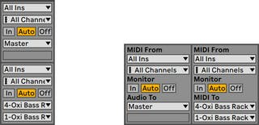The Track In/Out Section in the Arrangement (Left) and Session View (Right).

Audio tracks default to recording a mono signal from external input 1 or 2. MIDI tracks default to recording all MIDI that is coming in through the active external input devices ([see 15.3.1](https://www.ableton.com/en/manual/routing-and-i-o/#15-3-1-the-midi-ports-list-in-the-preferences)). The computer keyboard can be activated as a pseudo-MIDI input device ([see 15.3.2](https://www.ableton.com/en/manual/routing-and-i-o/#15-3-2-playing-midi-with-the-computer-keyboard)), allowing you to record MIDI even if no MIDI controller hardware is currently available.

For every track, you can choose an input source other than the default: any mono or stereo external input, a specific MIDI channel from a specific MIDI-in device or a signal coming from another track. The Routing chapter ([see Chapter 15](https://www.ableton.com/en/manual/routing-and-i-o/)) describes these options in detail.

**17.2 Arming (Record-Enabling) Tracks**

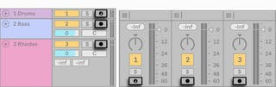Track Arm Buttons in the Arrangement (Left) and Session (Right) Mixers.

To select a track for recording, click on its Arm button. It doesn’t matter if you click a track’s Arm button in the Session View or in the Arrangement View, since the two share the same set of tracks.

By default, armed tracks are monitored, meaning that their input is passed through their device chain and to the output, so that you can listen to what is being recorded. This behavior is called “auto-monitoring“ and you can change it to fit your needs ([see 15.1](https://www.ableton.com/en/manual/routing-and-i-o/#15-1-monitoring)).

If you are using a natively supported control surface, arming a MIDI track will automatically lock this control surface to the instrument in the track ([see 29.1.1](https://www.ableton.com/en/manual/midi-and-key-remote-control/#29-1-1-natively-supported-control-surfaces)).

Clicking one track’s Arm button unarms all other tracks unless the CTRL(Win) / CMD(Mac) modifier is held. If multiple tracks are selected, clicking one of their Arm buttons will arm the other tracks as well. Arming a track selects the track so you can readily access its devices in the Device View.

**17.3 Recording**

Recording can be done in both the Session and the Arrangement Views. If you want to record onto more than one track simultaneously and/or prefer viewing the recording linearly and in-progress, the Arrangement View may be the better choice. If you want to break your recording seamlessly into multiple clips or record while you are also launching clips in Live, use the Session View.

**17.3.1 Recording Into the Arrangement**

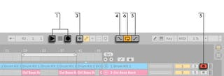Recording Into the Arrangement.

1. Pressing the Control Bar’s Arrangement Record button starts recording. The specific behavior depends on the state of the “Start Playback with Record” button in the Record/Warp/Launch preferences. When enabled, recording starts as soon as the button is pressed. When disabled, recording will not start until the Play button is pressed (or Session clips are launched.) Tip: regardless of the state of this preference, holding Shift while pressing Arrangement Record will engage the opposite behavior.
2. Recording creates new clips in all tracks that have their Arm button on.
3. When MIDI Arrangement Overdub is enabled, new MIDI clips contain a mix of the signal already in the track and the new input signal. Note that overdubbing only applies to MIDI tracks.
4. To prevent recording prior to a punch-in point, activate the Punch-In switch. This is useful for protecting the parts of a track that you do not want to record over and allows you to set up a pre-roll or “warm-up“ time. The punch-in point is identical to the Arrangement Loop’s start position.
5. Likewise, to prevent recording after the punch-out point, activate the Punch-Out switch. The punch-out point is identical to the Arrangement Loop’s end position.
6. When you are recording into the Arrangement Loop ([see 6.5](https://www.ableton.com/en/manual/arrangement-view/#6-5-the-arrangement-loop)), Live retains the audio recorded during each pass.

You can later “unroll“ a loop recording, either by repeatedly using the Edit menu’s Undo command or graphically in the Clip View: After loop recording, double-click on the new clip. In the Clip View’s Sample Editor, you can see a long sample containing all audio recorded during the loop-recording process. The Clip View’s loop brace defines the audio taken in the last pass; moving the markers left lets you audition the audio from previous passes.

**17.3.2 Recording Into Session Slots**

You can record new clips, on the fly, into any Session slots.

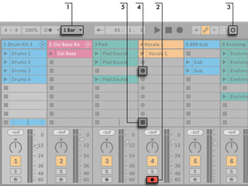Recording Into the Session View.

1. Set the Global Quantization chooser to any value other than “None“ to obtain correctly cut clips.
2. Activate the Arm button for the tracks onto which you want to record. Clip Record buttons will appear in the empty slots of the armed tracks.
3. Click the Session Record button to record into the selected scene in all armed tracks. A new clip will appear in each clip slot, with a red Clip Launch button that shows it is currently recording. To go from recording immediately into loop playback, press the Session Record button again.
4. Alternatively, you can click on any of the Clip Record buttons to record into that slot. To go from recording immediately into loop playback, press the clip’s Launch button.
5. To stop a clip entirely, press its Clip Stop button or the Stop button in the Control Bar.

It is possible to stop playback and prepare for a new “take” with the New button. The New button stops clips in all armed tracks and selects a scene where new clips can be recorded, creating a new scene if necessary. Note that the New button is only available in Key Map Mode and MIDI Map Mode. Detailed steps for creating keyboard assignments are available in Computer Keyboard Remote Control ([see 29.2.5](https://www.ableton.com/en/manual/midi-and-key-remote-control/#29-2-5-computer-keyboard-remote-control)). Please refer to MIDI and Key Remote Control ([see 29.1](https://www.ableton.com/en/manual/midi-and-key-remote-control/#29-1-midi-remote-control)) for more information about MIDI assignments.

The New Button Appears in the Control Bar When Key Map Mode Is Active.

Note that, by default, launching a Session View scene will not activate recording in empty record-enabled slots belonging to that scene. However, you can use the Start Recording on Scene Launch option from the Record/Warp/Launch Preferences to tell Live that you do want empty scene slots to record under these circumstances.

**17.3.3 Overdub Recording MIDI Patterns**

Live makes pattern-oriented recording of drums and the like quite easy. Using Live’s Impulse instrument and the following technique, you can successively build up drum patterns while listening to the result. Or, using an instrument such as Simpler, which allows for chromatic playing, you can build up melodies or harmonies, note by note.

1. Set the Global Quantization chooser to one bar.
2. To automatically quantize the notes you are about to record, choose an appropriate value for Record Quantization ([see 17.5](https://www.ableton.com/en/manual/recording-new-clips/#17-5-recording-quantized-midi-notes)).
3. Double-click any of the Session View slots in the desired MIDI track (the one containing the Impulse or other instrument). A new, empty clip will appear in the slot. The new clip will default to a loop length of one bar, but you can change that by double-clicking the clip and changing its loop properties ([see 8.3](https://www.ableton.com/en/manual/clip-view/#8-3-the-notes-tab-panel)).
4. Arm the track.
5. Press the Session Record button.
6. The notes you play are added into the looping clip, and you can observe your recording in the Clip View.
7. The clip overdubs as it loops, allowing you to build your pattern layer by layer. However, if you would like to pause recording for a moment to rehearse, you can deactivate overdubbing by pressing the Session Record button again. The contents of the clip will continue to play, but you can play along without being recorded. When you are ready to record again, press the Session Record button once again. Subsequent presses of the Session Record button will toggle between playback and overdub.

Note that holding ALT(Win) / ALT(Mac) while double-clicking the empty slot to create a new clip will implicitly arm the track and launch the clip.

At any time while overdub recording is going on, you can use the Undo command to remove the last take, or even draw, move or delete notes in the Clip View’s MIDI Note Editor.

**17.3.4 MIDI Step Recording**

The MIDI Editor allows you to record notes with the transport stopped by holding down keys on your controller or computer MIDI keyboard and advancing the insert marker according to the grid settings. This process, known as step recording, allows you to enter notes at your own pace, without needing to listen to a metronome or guide track.

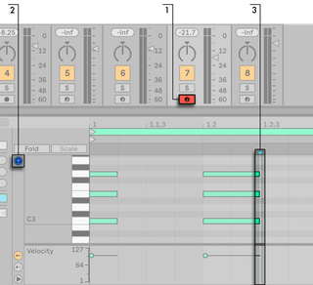Step Recording in the MIDI Editor.

1. Arm the MIDI track that contains the clip into which you want to record.
2. Enable the Preview switch in the clip’s MIDI Editor.
3. Click in the MIDI Editor to place the insert marker at the position where you want to begin recording.

Pressing the right arrow key on your computer keyboard will move the insert marker to the right, according to the grid settings. Any notes that are held down as you press the right arrow key will be added to the clip. If you continue holding notes as you press the right arrow key again, you will extend their duration. To delete notes that you’ve just recorded, keep them depressed and press the left arrow key.

The step recording navigators can also be MIDI mapped ([see 17.9](https://www.ableton.com/en/manual/recording-new-clips/#17-9-using-remote-control-for-recording)).

**17.4 Recording in Sync**

Live keeps the audio and MIDI you have recorded in sync, even when you later decide on a different song tempo. In fact, Live allows you to change the tempo at any time before, after and even during recording. You could, for instance, cheat a bit by turning down the tempo to record a technically difficult part, and pull it up again afterwards.

It is important to *record in sync* to make sure everything will later *play in sync*.

The Metronome Switch.

The easiest way to record in sync is to play along with or to use the built-in metronome, which is activated via its Control Bar switch and will begin ticking when the Play button is pressed or a clip is launched.

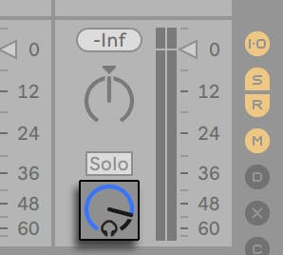The Preview Volume Knob.

To adjust the metronome volume, use the mixer’s Preview Volume knob. Further metronome settings can be adjusted via the pull-down menu next to the metronome switch.

Notice that Live’s metrical interpretation of the material in a clip can be edited, at any time, using Warp Markers ([see 9.2.2](https://www.ableton.com/en/manual/audio-clips-tempo-and-warping/#9-2-2-warp-markers)). Warp Markers can be used to fix timing errors and to change the groove or feel of your audio or MIDI recordings. Using Warp Markers, you can fix things that would otherwise require complicated editing or could not be done at all.

**17.4.1 Metronome Settings**

You can access the Metronome Settings menu via the pull-down switch next to the metronome, or by opening the context menu via right-click(Win) / CTRL-click(Mac) on the metronome itself.

The menu lets you set the count-in length for recording ([see 17.6](https://www.ableton.com/en/manual/recording-new-clips/#17-6-recording-with-count-in)). You can also change the sound of the metronome’s tick.

The *Rhythm* settings allow you to set the beat division at which the metronome ticks. With the default “Auto” setting, the tick interval follows the time signature’s denominator. Beat divisions that do not fit into one bar of the current time signature will appear disabled.

If the currently selected beat division no longer fits in a bar due to a time signature change, the metronome’s tick will revert to the “Auto” setting. However, if the time signature is changed in a way that makes the beat division fit in a bar again, the tick will revert to following the selected beat division.

When Enable Only While Recording is checked and the metronome is activated, the metronome will be highlighted while transport is running, but will only be audible while recording. If you are recording into the Arrangement while the Punch-In switch is active, the metronome will only be audible after the punch-in point.

**17.5 Recording Quantized MIDI Notes**

If you will be recording MIDI, you have the option of automatically quantizing MIDI notes while recording. The Record Quantization chooser in the Edit menu allows selecting the meter subdivisions with which your recorded notes will align. When recording into the Arrangement, record quantization is an independent step in Live’s Undo history. This means that if, for example, you recorded with Record Quantization set to “Eighth Note Triplet Quantization“ and then changed your mind, using the Edit menu’s Undo command would undo only the quantization and leave your recording otherwise intact.

For Session and Arrangement recording, the Record Quantization setting cannot be changed mid-recording.

When overdub recording with the Clip View Loop activated, changes to the Record Quantization take effect immediately, and they cannot be separately undone with the Edit menu command.

Recorded MIDI notes can also be quantized post-recording with the Edit menu’s Quantize command, as described in the chapter on editing MIDI ([see 10.4.7](https://www.ableton.com/en/manual/editing-midi-notes-and-velocities/#10-4-7-quantizing-notes)).

**17.6 Recording with Count-in**

A count-in for recording can be set via the pull-down menu next to the Metronome switch. When set to any value other than “None,“ Live will not begin recording until the count-in is complete. The Arrangement Position fields in the Control Bar display the count-in in blue as bars-beats-sixteenths.

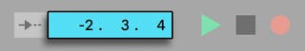The Count-In is Displayed in the Control Bar.

The count-in runs from negative bars-beats-sixteenths (beginning at -2.1.1., for example, with a Count-In setting of 2 bars) up to 1.1.1., at which point recording commences.

**17.7 Setting up File Types**

The following Preferences from the Record/Warp/Launch tab are relevant to the sample files that are created by recording:

* The sample file type you would like Live to create can be chosen from the File Type chooser in the Record/Warp/Launch Preferences.
* The bit depth of the sample file you will create by recording can be chosen from the Bit Depth chooser in the Record/Warp/Launch Preferences.

You can save time by setting up reasonable defaults for the clips you are recording in the Record/Warp/Launch Preferences tab. In particular, it is smart to indicate the rough category of sound to be recorded by choosing the appropriate default *Warp Mode*. If you decide later on a different song tempo, the program will automatically maintain good sound quality ([see 9.3](https://www.ableton.com/en/manual/audio-clips-tempo-and-warping/#9-3-adjusting-for-good-stretching-quality)), usually without further adjustment.

**17.8 Where are the Recorded Samples?**

Recorded samples are stored with the current Set’s Project folder, under Samples/Recorded. Until the Set is saved, it remains at the location specified by the Temporary Folder preference which is found in the Preferences’ File/Folder tab. To make sure Live will not run out of disk space while recording into a new Set, please make sure the Temporary Folder is on a drive/partition with sufficient free space.

**17.9 Using Remote Control for Recording**

Using Key Map Mode and MIDI Map Mode ([see Chapter 29](https://www.ableton.com/en/manual/midi-and-key-remote-control/)), you can operate Live’s recording functions without using the mouse.

You can map the Control Bar’s Arrangement Record and transport controls as well as the track Arm buttons. For recording into the Session slots, you can map the Session Record and New buttons, the individual slots, and the relative navigation controls to initiate recording remotely; for instance:

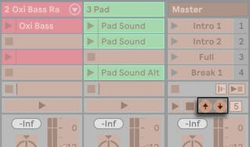The Scene Up/Down Buttons.

One key is used to jump to the next scene...

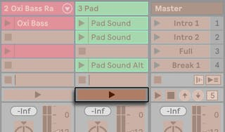A Track Launch Button.

... and another key to start and end recording in the respective track.

You can also map the step recording navigators ([see 17.3.4](https://www.ableton.com/en/manual/recording-new-clips/#17-3-4-midi-step-recording)).

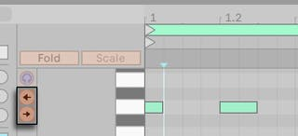The Step Recording Arrows.

This allows you to, for example, use MIDI foot pedals to move the clip’s insert marker, thereby keeping both hands free for playing a keyboard.

**17.10 Capturing MIDI**

Live is always listening to MIDI input on armed ([see 17.2](https://www.ableton.com/en/manual/recording-new-clips/#17-2-arming-record-enabling-tracks)) or input-monitored tracks ([see 15.1](https://www.ableton.com/en/manual/routing-and-i-o/#15-1-monitoring)), and Capture MIDI lets you retrieve the material you’ve just played on those tracks. This is particularly useful if you forgot to press the Record button before playing, or if you prefer to improvise or experiment freely without the stress of recording.

The Capture MIDI Button in the Control Bar.

To capture the MIDI notes you just played, press the Capture MIDI button. (Note: on Push ([see Chapter 30](https://www.ableton.com/en/manual/using-push/)) or Push 2 ([see Chapter 31](https://www.ableton.com/en/manual/using-push-2/)), you can trigger Capture MIDI by holding the Record button and pressing the New button.)

Capture MIDI behaves differently depending on the state of the Live Set. We will look at these different behaviors below.

**17.10.1 Starting a New Live Set**

If the Live Set contains no other clips and the transport is stopped:

* A new clip containing the phrase you played will be created on every monitored MIDI track. Note that Capture MIDI will only add clips to the Session or Arrangement View, depending on which View is currently in focus.
* Capture MIDI will detect and adjust the song tempo, set appropriate loop boundaries and place the played notes on the grid. Note that Capture MIDI’s tempo detection will set the tempo in the 80-160 BPM range. If you consider the played material to be at a tempo outside this range, you can adjust the song tempo to your liking. (Tip: to help Capture MIDI detect a phrase correctly, it is recommended to end playing on the first beat (or “downbeat”) of the next bar.)
* Live’s transport will immediately begin to run, and play back the captured loop. This allows you to create overdubs if you wish (for more information about overdubbing with Capture MIDI, refer to the section Adding Material to an Existing Live Set below).
* All of your played material will be saved in the clip, and any notes that you played before the detected phrase will appear prior to the clip start marker. This enables you to adjust the start/end or loop markers to set a different loop. (Tip: to discard unwanted material outside the set loop, simply right-click(Win) / CTRL-click(Mac) on the clip and select the Crop Clip command.)

Note: If only one note is played in the first captured MIDI clip, the loop boundaries are set to the note start and end, and the tempo is accordingly calculated, resulting in a one, two, four, or eight bar loop. This is particularly useful when playing a rhythmical sample with a single MIDI note.

**17.10.2 Adding Material to an Existing Live Set**

If Live’s transport is running, there are already other clips in the Live Set, or the tempo is automated ([see 21.5.8](https://www.ableton.com/en/manual/automation-and-editing-envelopes/#21-5-8-editing-the-tempo-automation)) :

* Capture MIDI will not detect or adjust the song tempo. Instead, Capture MIDI will use the existing tempo to detect a meaningful musical phrase from your played material and create a loop.
* While the transport is running, you can “play along” with other clips. You can also use Capture MIDI to “overdub” a playing clip, by playing over it on the same track. Pressing the Capture MIDI button will add the material you just played on top of the existing clip’s content, allowing you to build your pattern layer by layer.
* All of your played material will be saved in the clip, and any notes that you played before the detected phrase will appear prior to the clip start marker. This allows you to adjust the start/end or loop markers to set a different loop.

.8 Browser -Firefox/Chrome/Edge/Safari how to use their tools

and techniques.

# **Firefox DevTools User Docs**[**¶**](https://firefox-source-docs.mozilla.org/devtools-user/index.html#firefox-devtools-user-docs)

Firefox Developer Tools is a set of web developer tools built into Firefox. You can use them to examine, edit, and debug HTML, CSS, and JavaScript.

This section contains detailed guides to all of the tools as well as information on how to debug Firefox for Android, how to extend DevTools, and how to debug the browser as a whole.

If you have any feedback on DevTools or want to contribute to the project, you can [join the DevTools community](https://firefox-dev.tools/).

**Note**

If you are just getting started with web development and using developer tools, our [learning](https://developer.mozilla.org/en-US/docs/Learn) docs will help you — see [Getting started with the Web](https://developer.mozilla.org/en-US/docs/Learn/Getting_started_with_the_web) and [What are browser developer tools?](https://developer.mozilla.org/en-US/docs/Learn/Common_questions/What_are_browser_developer_tools) for good starting points.

**The Core Tools**[**¶**](https://firefox-source-docs.mozilla.org/devtools-user/index.html#the-core-tools)

You can open the Firefox Developer Tools from the menu by selecting **Tools > Web Developer > Web Developer Tools** or use the keyboard shortcut **Ctrl** + **Shift** + **I** or **F12** on Windows and Linux, or **Cmd** + **Opt** + **I** on macOS.

The ellipsis menu on the right-hand side of Developer Tools contains several commands that let you perform actions or change tool settings.

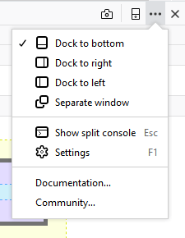

|  |  |
| --- | --- |
| image1 | This button only appears when there are multiple iframes on a page. Click it to display a list of the iframes on the current page and select the one with which you want to work. |
| image2 | Click this button to take a screenshot of the current page. (*Note:* This feature is not turned on by default and must be enabled in settings before the icon will appear.) |
| image3 | Toggles Responsive Design Mode |
| image4 | Opens the menu that includes docking options, the ability to show or hide the split console, and Developer Tools settings. The menu also includes links to the documentation for Firefox Web Tools and the Mozilla Community. |
| image5 | Closes the Developer Tools |

**Page Inspector**[**¶**](https://firefox-source-docs.mozilla.org/devtools-user/index.html#page-inspector)

[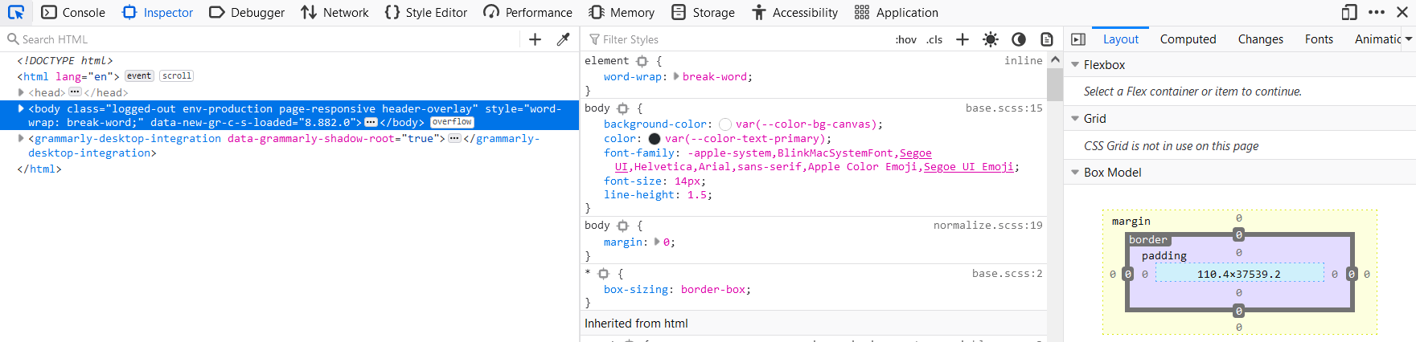](https://firefox-source-docs.mozilla.org/devtools-user/page_inspector)

View and edit page content and layout. Visualize many aspects of the page including the box model, animations, and grid layouts

**Web Console**[**¶**](https://firefox-source-docs.mozilla.org/devtools-user/index.html#web-console)

[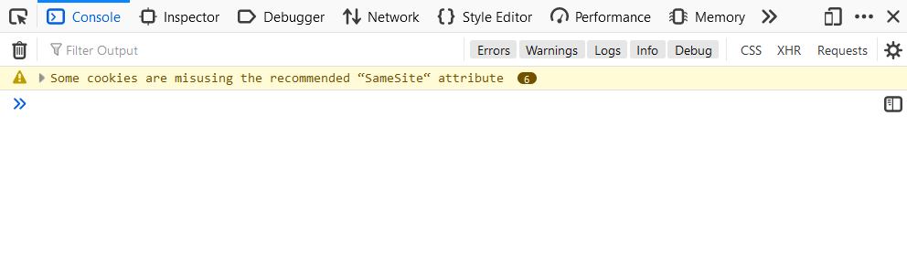](https://firefox-source-docs.mozilla.org/devtools-user/web_console)

See messages logged by a web page and interact with the page using JavaScript.

**JavaScript Debugger**[**¶**](https://firefox-source-docs.mozilla.org/devtools-user/index.html#javascript-debugger)

[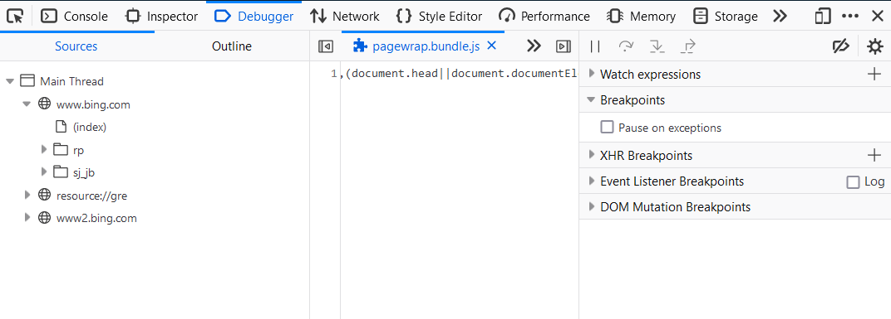](https://firefox-source-docs.mozilla.org/devtools-user/debugger)

Stop, step through, and examine the JavaScript running on a page.

**Network Monitor**[**¶**](https://firefox-source-docs.mozilla.org/devtools-user/index.html#network-monitor)

[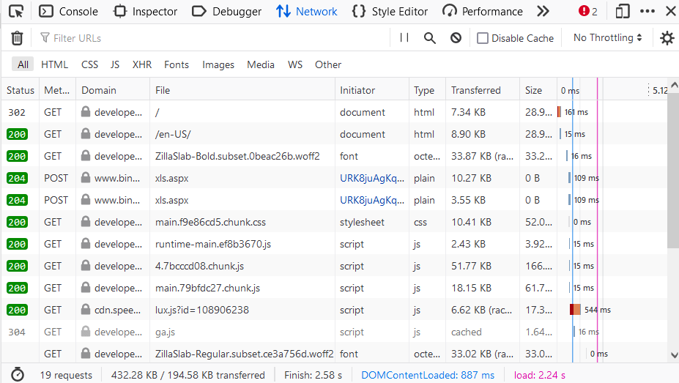](https://firefox-source-docs.mozilla.org/devtools-user/network_monitor)

See the network requests made when a page is loaded.

**Performance Tools**[**¶**](https://firefox-source-docs.mozilla.org/devtools-user/index.html#performance-tools)

[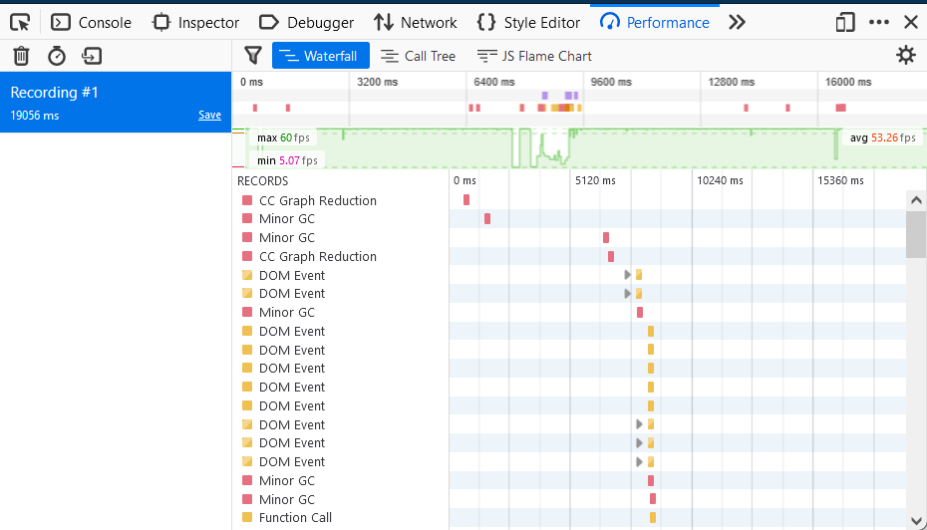](https://firefox-source-docs.mozilla.org/devtools-user/performance)

Analyze your site’s general responsiveness, JavaScript, and layout performance.

**Responsive Design Mode**[**¶**](https://firefox-source-docs.mozilla.org/devtools-user/index.html#responsive-design-mode)

[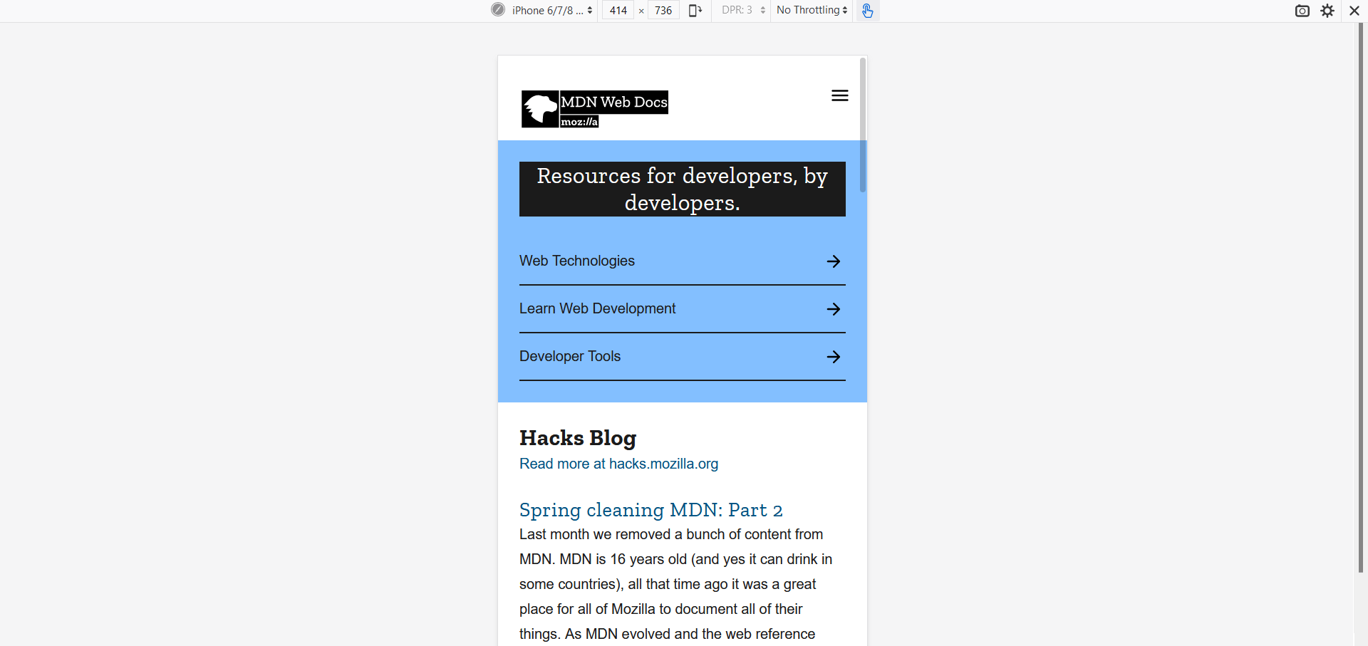](https://firefox-source-docs.mozilla.org/devtools-user/responsive_design_mode)

See how your website or app will look and behave on different devices and network types.

**Accessibility inspector**[**¶**](https://firefox-source-docs.mozilla.org/devtools-user/index.html#accessibility-inspector)

[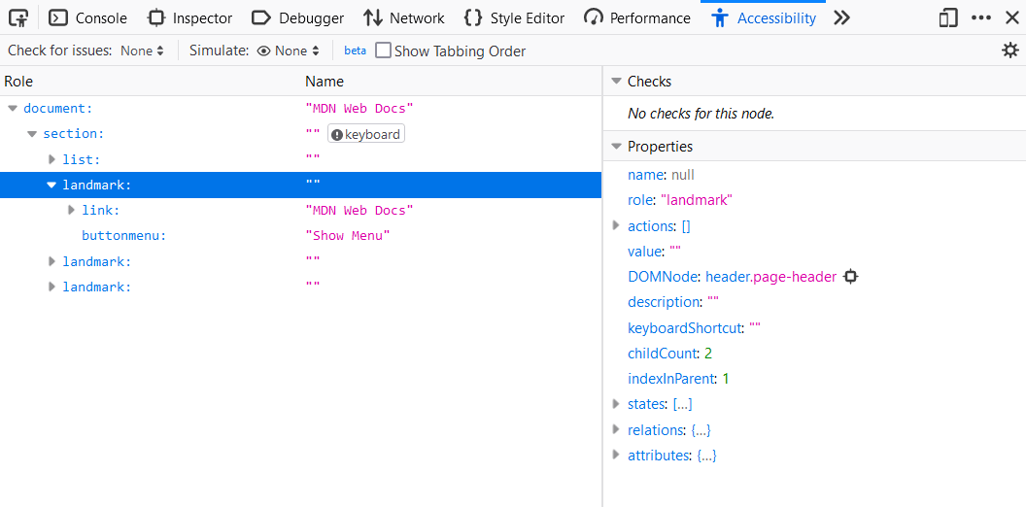](https://firefox-source-docs.mozilla.org/devtools-user/accessibility_inspector)

Provides a means to access the page’s accessibility tree, allowing you to check what’s missing or otherwise needs attention.

**Application panel**[**¶**](https://firefox-source-docs.mozilla.org/devtools-user/index.html#application-panel)

[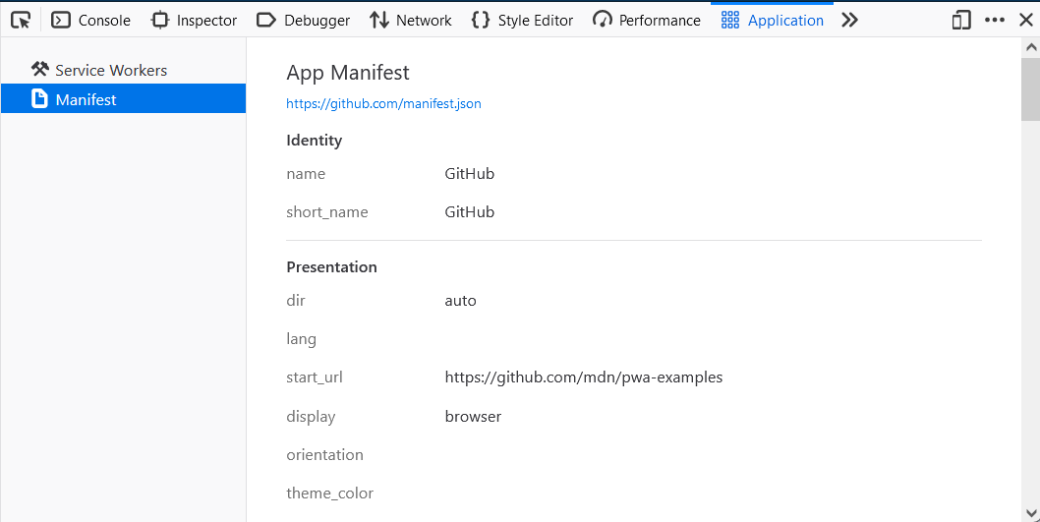](https://firefox-source-docs.mozilla.org/devtools-user/application)

Provides tools for inspecting and debugging modern web apps (also known as [Progressive Web Apps](https://developer.mozilla.org/en-US/docs/Web/Progressive_web_apps)). This includes inspection of [service workers](https://developer.mozilla.org/en-US/docs/Web/API/Service_Worker_API) and [web app manifests](https://developer.mozilla.org/en-US/docs/Web/Manifest)

How to Open the Developer Console

A developer console is a tool that logs information about the backend operations of our site and application. The information logged in the console can help our developers to solve any issue that you may experience.

If you've been asked to provide a screenshot of your developer console, scroll down to find instructions for the browser or application you're using.

**Chrome**

Step 1: To open the console in Chrome, use this keyboard shortcut: Cmd + Option + J (on a Mac) or Ctrl +Shift +J (on Windows). As an alternative, you can right-click on the webpage and click "Inspect" to open the developer console. 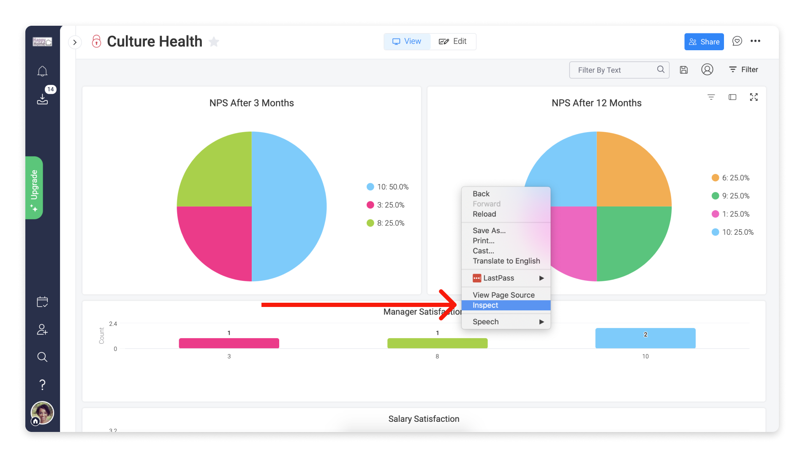

Step 2: Click the "Console" tab in that window.  
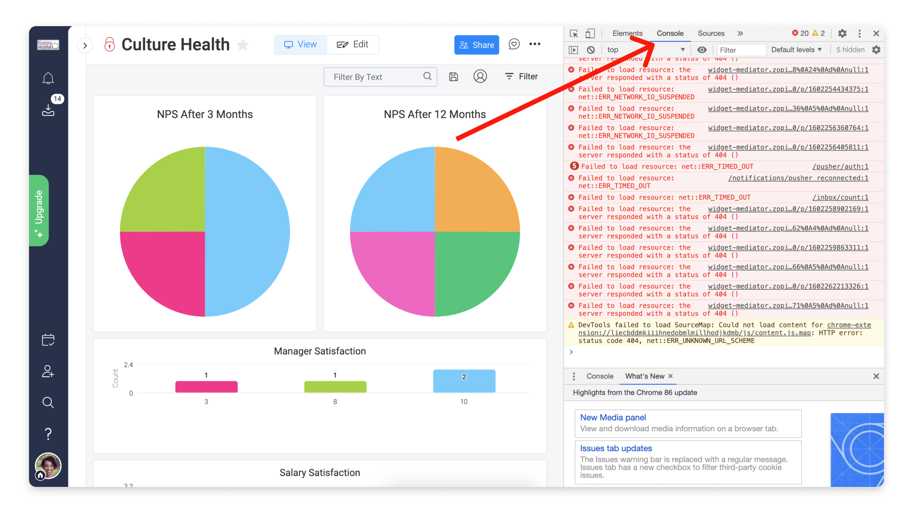

Step 3: From there, repeat the action that is causing you trouble and take a full screenshot of the Console dialogue.

**Firefox**

Step 1: To open the console in Firefox, use this keyboard shortcut: Cmd + Option +K (on a Mac) or Ctrl +Shift +J (on Windows). As an alternative, you can right-click on the webpage and click "Inspect Element" to show the developer window.  
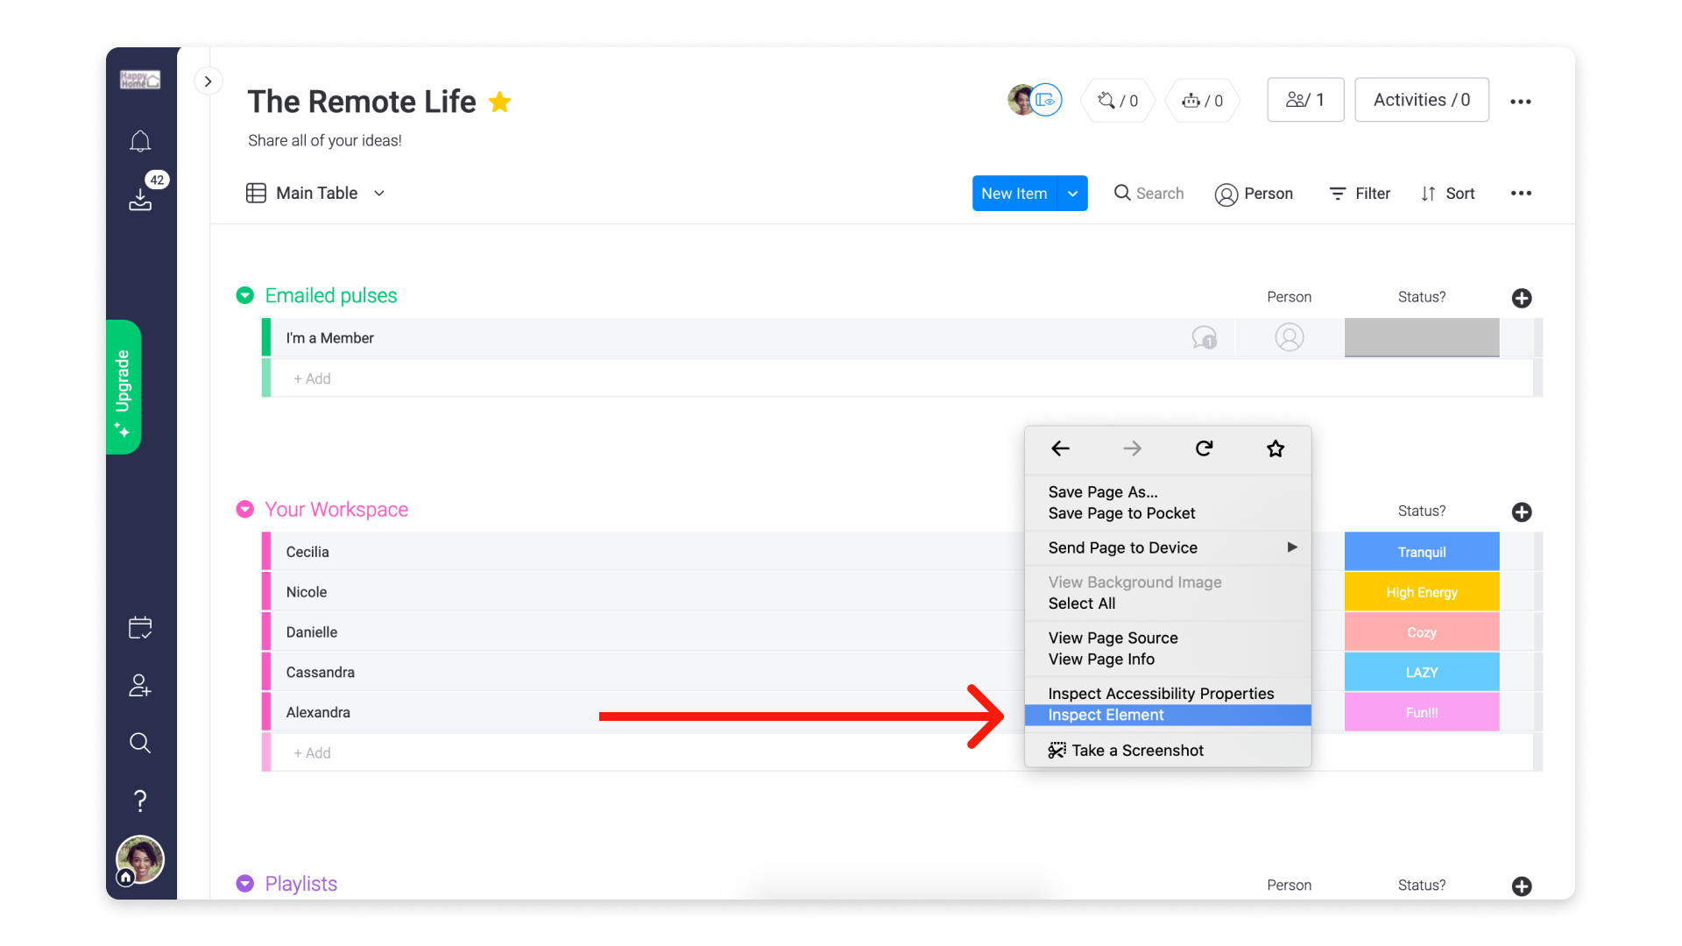

Step 2: Select the "Console" tab in that window.   
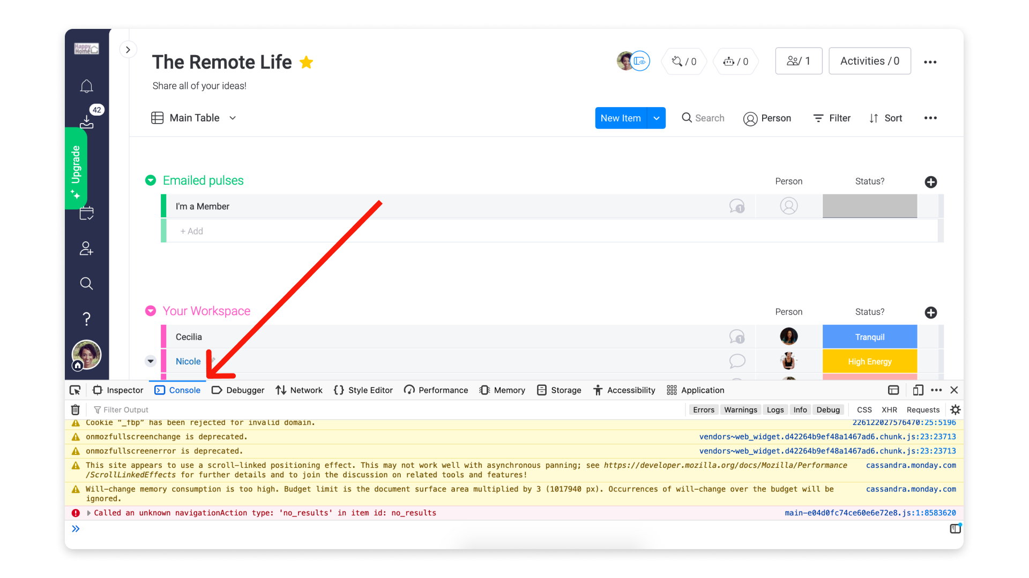  
Step 3: From there, repeat the action that is causing you trouble and take a full screenshot of the Console dialogue.

**Safari**

Step 1: To open the console in Safari, you must first enable the "Develop menu" in the Mac menu bar. To do this, go to Safari in the Mac menu bar at the top of your screen and then select "Preferences."  
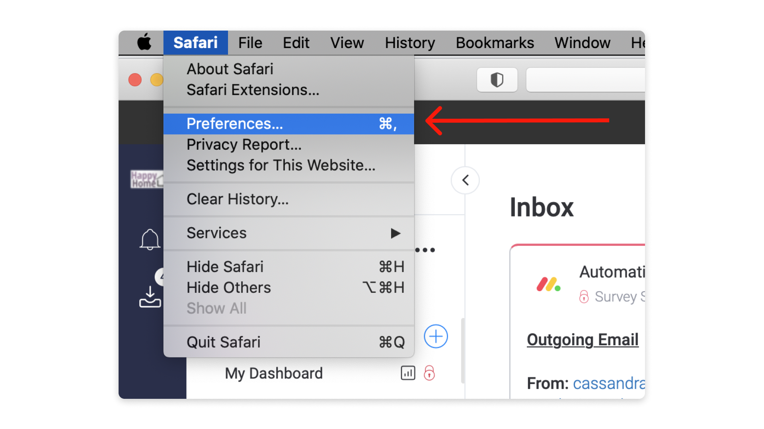

Step 2: Once you have the Preferences Dialog box open, click on "Advanced" at the top and then tick the checkbox next to "Show Develop menu in menu bar." You can then exit the window.  
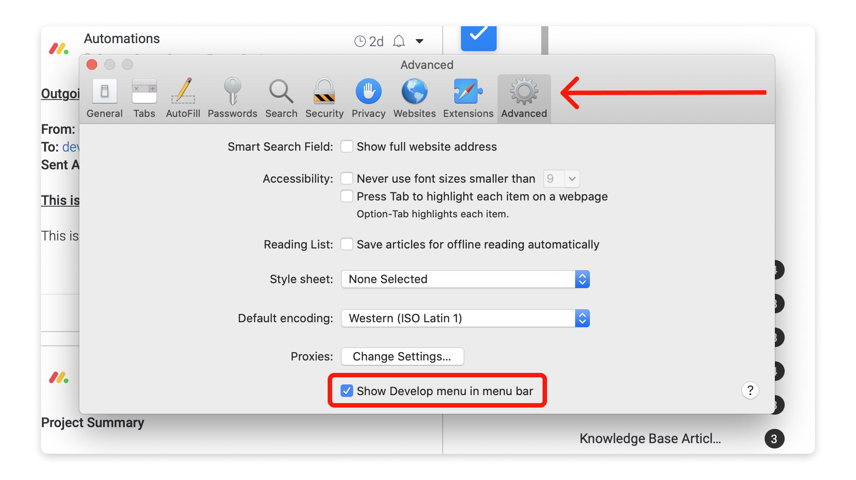

Step 3: To open the console, you can use this keyboard shortcut: Cmd + Option + C. As an alternative, you can right-click on the webpage and click "Inspect Element", and the developer window will appear.  
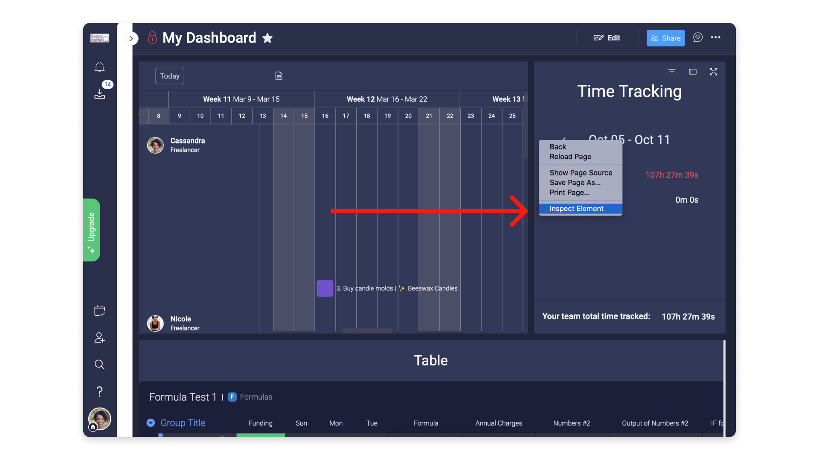

Step 4: In the window that opens, click the "Console" tab.  
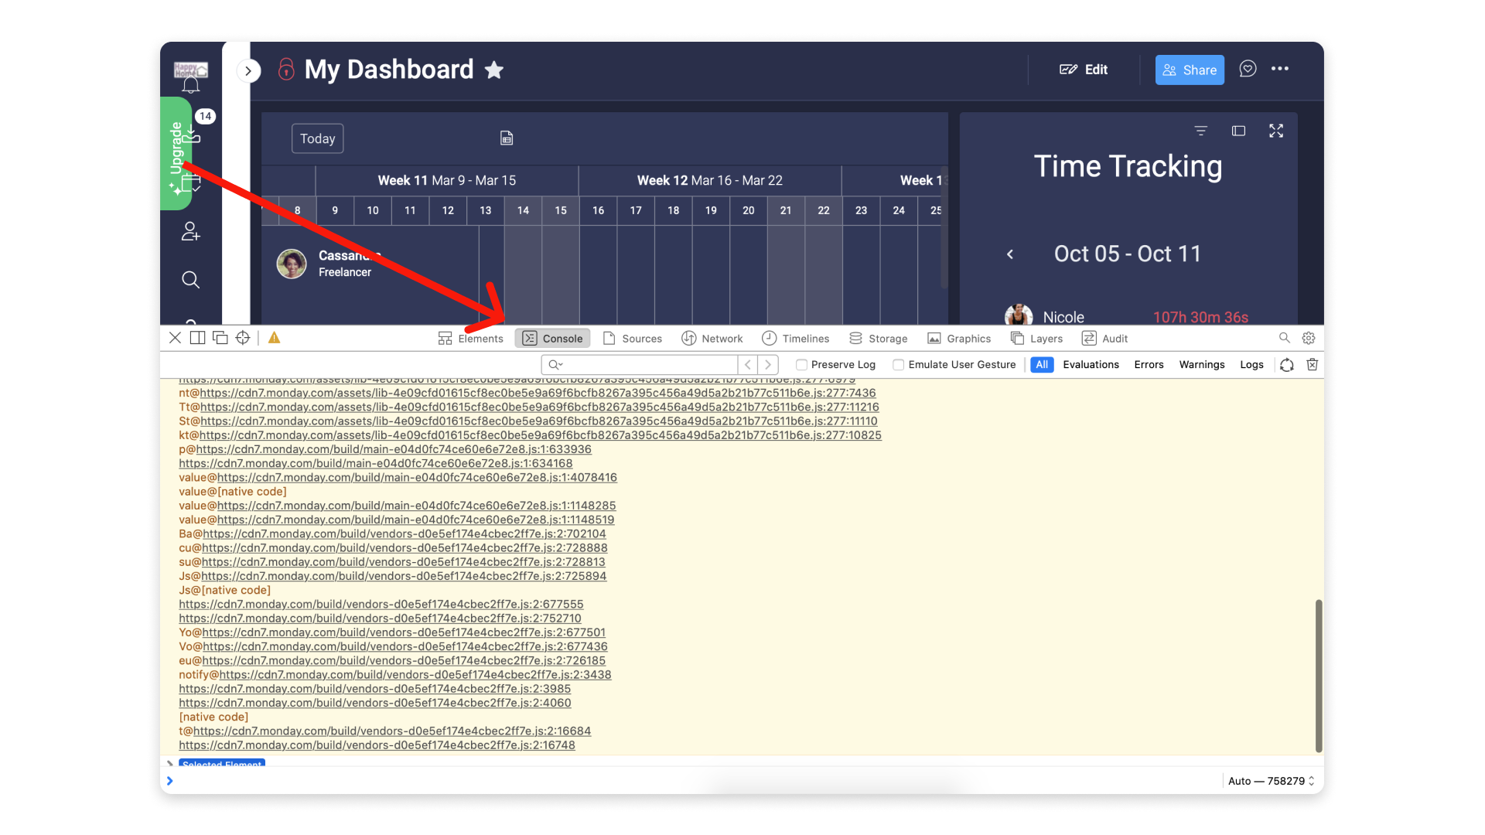

Step 5: From there, repeat the action that is causing you trouble and take a full screenshot of the Console dialogue.

**Microsoft Edge**

Step 1: To open the console in Microsoft Edge, you can use the following shortcut: Control + Shift + I. As an alternative, you can right-click and select Inspect from the menu:

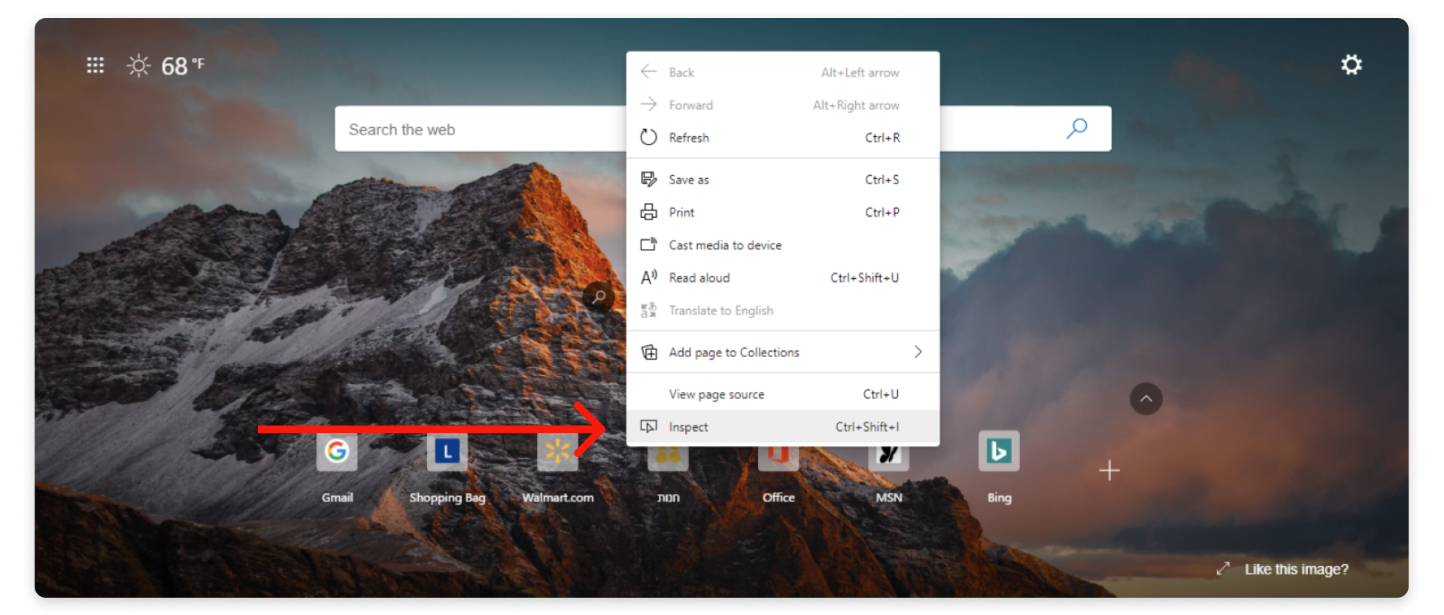

Step 2: In the window that opens, click the "Console" tab.

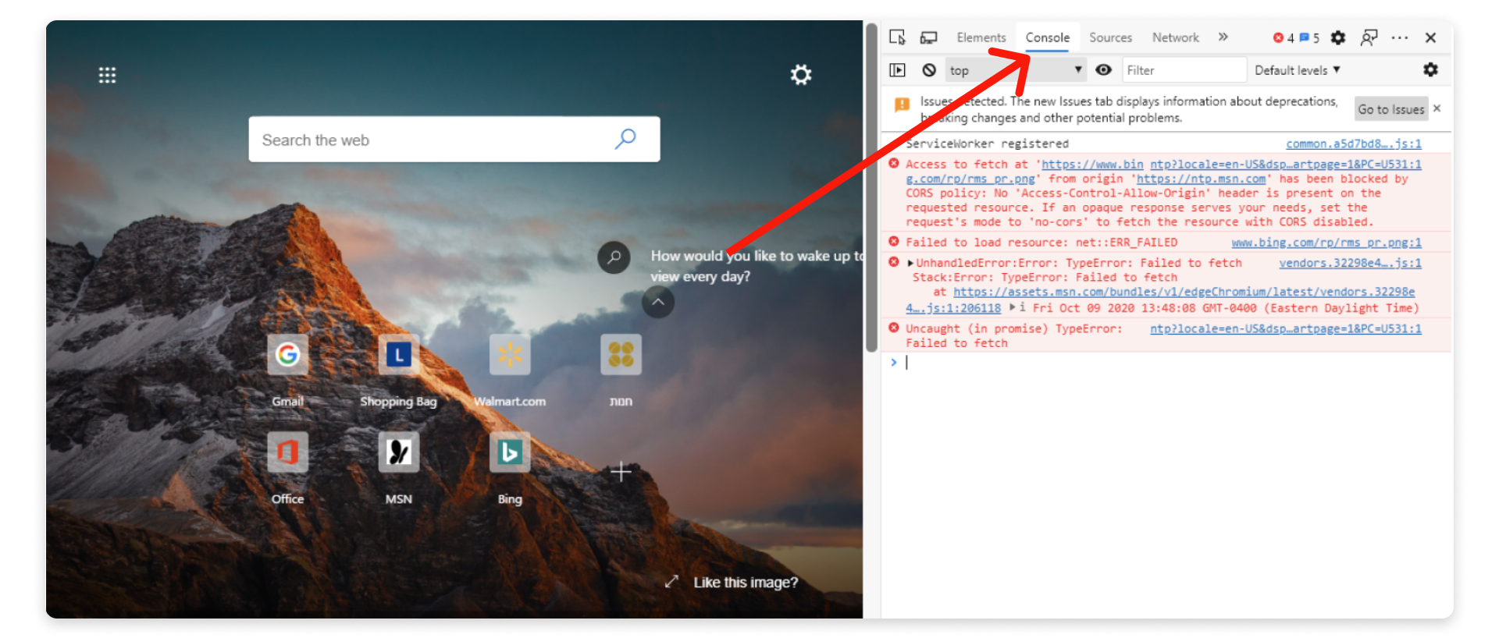

Step 3: From there, repeat the action that is causing you trouble and take a full screenshot of the Console dialogue.

**Desktop App**

Step 1: To open the console in the monday.com Desktop App, you can select "Developer Console" from the View menu on your toolbar.

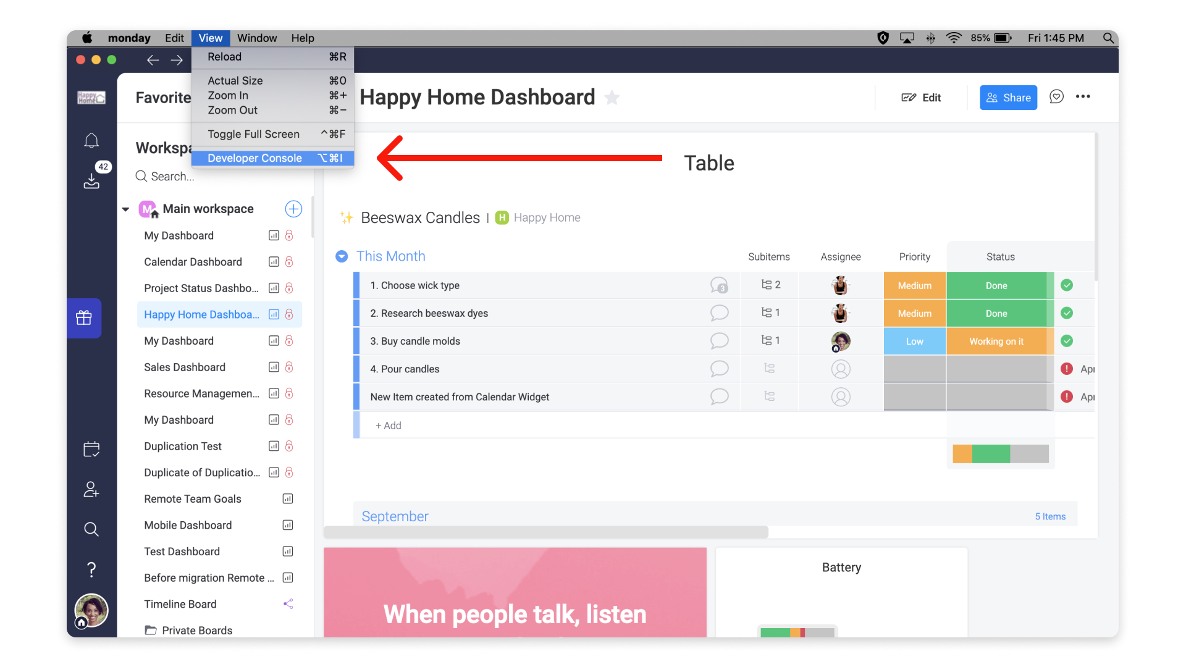

Step 2: The console will open in the main application window. However, a new window may open as well. In either window, click the "Console" tab.

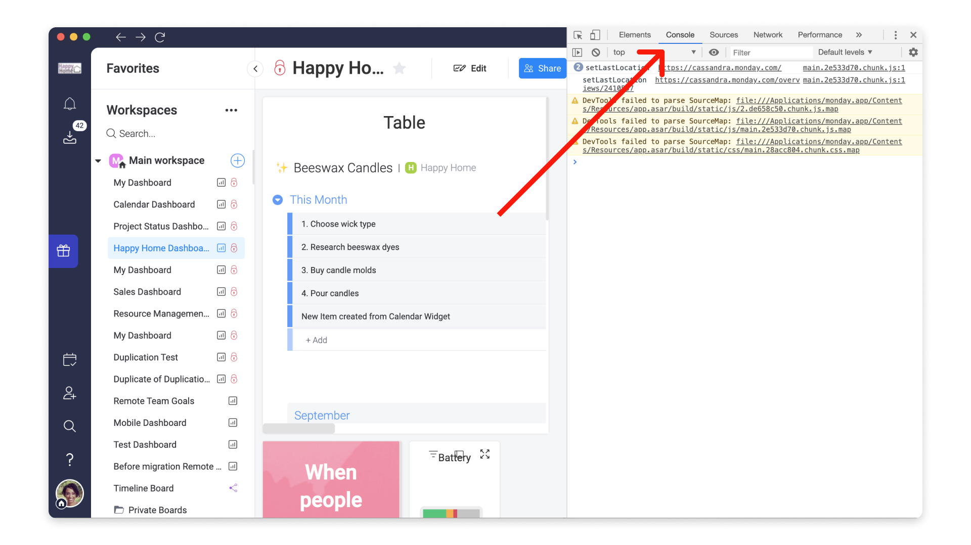

Step 3: From there, repeat the action that is causing you trouble and take a full screenshot of the Console dialogue.

How to Open the Developer Console

A developer console is a tool that logs information about the backend operations of our site and application. The information logged in the console can help our developers to solve any issue that you may experience.

If you've been asked to provide a screenshot of your developer console, scroll down to find instructions for the browser or application you're using.

**Chrome**

Step 1: To open the console in Chrome, use this keyboard shortcut: Cmd + Option + J (on a Mac) or Ctrl +Shift +J (on Windows). As an alternative, you can right-click on the webpage and click "Inspect" to open the developer console. 

Step 2: Click the "Console" tab in that window.  


Step 3: From there, repeat the action that is causing you trouble and take a full screenshot of the Console dialogue.

**Firefox**

Step 1: To open the console in Firefox, use this keyboard shortcut: Cmd + Option +K (on a Mac) or Ctrl +Shift +J (on Windows). As an alternative, you can right-click on the webpage and click "Inspect Element" to show the developer window.  


Step 2: Select the "Console" tab in that window.   
  
Step 3: From there, repeat the action that is causing you trouble and take a full screenshot of the Console dialogue.

**Safari**

Step 1: To open the console in Safari, you must first enable the "Develop menu" in the Mac menu bar. To do this, go to Safari in the Mac menu bar at the top of your screen and then select "Preferences."  


Step 2: Once you have the Preferences Dialog box open, click on "Advanced" at the top and then tick the checkbox next to "Show Develop menu in menu bar." You can then exit the window.  


Step 3: To open the console, you can use this keyboard shortcut: Cmd + Option + C. As an alternative, you can right-click on the webpage and click "Inspect Element", and the developer window will appear.  


Step 4: In the window that opens, click the "Console" tab.  


Step 5: From there, repeat the action that is causing you trouble and take a full screenshot of the Console dialogue.

**Microsoft Edge**

Step 1: To open the console in Microsoft Edge, you can use the following shortcut: Control + Shift + I. As an alternative, you can right-click and select Inspect from the menu:



Step 2: In the window that opens, click the "Console" tab.



Step 3: From there, repeat the action that is causing you trouble and take a full screenshot of the Console dialogue.

**Desktop App**

Step 1: To open the console in the monday.com Desktop App, you can select "Developer Console" from the View menu on your toolbar.



Step 2: The console will open in the main application window. However, a new window may open as well. In either window, click the "Console" tab.



Step 3: From there, repeat the action that is causing you trouble and take a full screenshot of the Console dialogue.

**20 top tips to help you master your Mac**

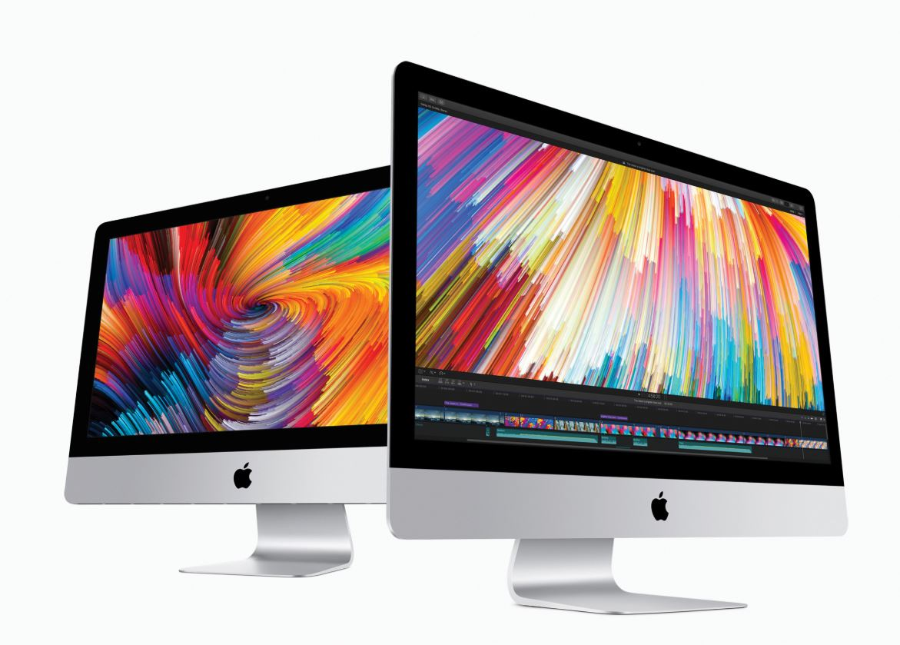***Macs are more popular than ever before - but for people still making the switch from Windows to Apple’s OS for the first time there can be a lot to take in. Here are 20 of our top tips to help you master your Mac***

**1. Take a screenshot of a specific part of the screen**

**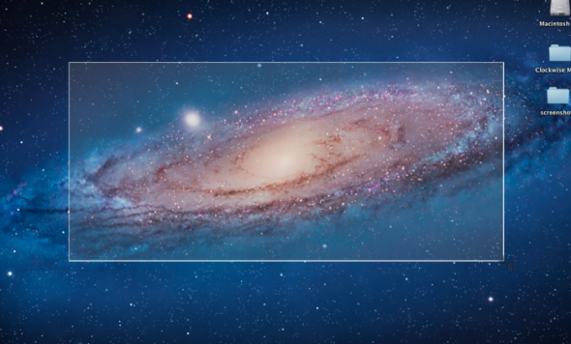**

Taking a screenshot is all well and good, but more often than not you don’t actually need the whole screen in the capture. On Macs there’s a simple way to grab just the part of the screen you want: **Cmd + Shift + 4**.

From there, click and drag out a box over the part of your screen you wish to capture. Upon release the image will be saved to the desktop. If you do just want to grab the whole screen, press **Cmd + Shift + 3** instead.

**2. Rename large batches of files all at once**

**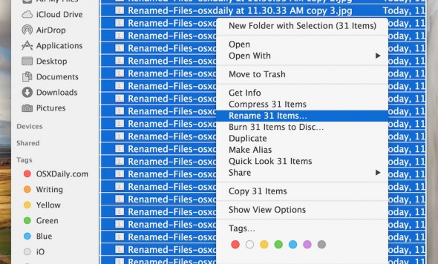**

Renaming files is tedious at best. Renaming a hundred holiday snaps in one sitting is downright torturous. If you’re running a Mac with Yosemite or later, you can do it with one simple action.

***Tech tips you can trust - get our***[***free Tech newsletter***](https://signup.which.co.uk/wlp-technewsletter?_its=JTdCJTIydmlkJTIyJTNBJTIyMTliNjg1YzUtODZiMS00OTQ3LWIxZGQtOTU4NmNkMjlhZTY5JTIyJTJDJTIyc3RhdGUlMjIlM0ElMjJybHR%2BMTY1MjgxODE2NX5sYW5kfjJfNzE1NDlfc2VvXzU2ODY1NmQwZGZjN2QxMzBlMjIyMGU5MDYzMThlYzVlJTIyJTJDJTIyc2l0ZUlkJTIyJTNBODgwNCU3RA%3D%3D)***for advice, news, deals and stuff the manuals don’t tell you***

Select all the files you want to rename and ctrl-click (or right-click) them, then click **Rename**. This presents you with three options for renaming. **Replace Text** allows you to change, for example, the ‘IMG’ part of a set of files with something more relevant. Thus ‘IMG\_01’, ‘IMG\_02’ and so on become ‘Dad’s birthday\_01’ and ‘Dad’s birthday\_02’, or somesuch.

**3. Run Windows on your Apple machine**

**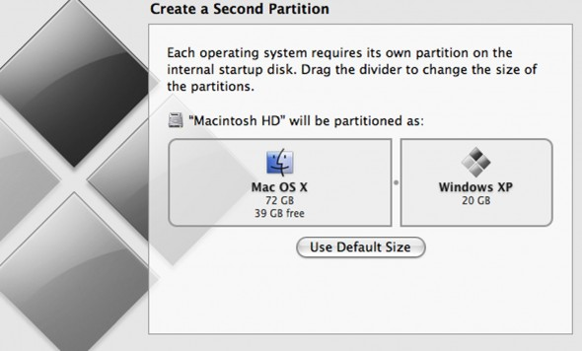**

Contrary to popular belief, it is possible to run a copy of Microsoft Windows on a Mac. It’s also surprisingly simple to do.

Navigate to the **Applications** folder on your Mac, and then to the **Utilities** folder. Within that is a programme called **Boot Camp**. It will now ‘partition’ your hard drive – this essentially means split it between Windows and Mac. You can choose how you split the ratio, but remember that storage allocated to one OS is not accessible by the other. Click **Partition** to start the process.

Upon restarting your Mac will ask for a Windows installation CD. If you don’t have one you will need to buy one - make sure it's Windows 10. When it asks where it should install select the partitioned section of your hard drive.

***Want some more help with your Mac? Our friendly tech team can help you with one-to-one support on a range of tech issues. Find out more***[***here***](http://try.which.co.uk/tech-support?_its=JTdCJTIydmlkJTIyJTNBJTIyMTliNjg1YzUtODZiMS00OTQ3LWIxZGQtOTU4NmNkMjlhZTY5JTIyJTJDJTIyc3RhdGUlMjIlM0ElMjJybHR%2BMTY1MjgxODE2NX5sYW5kfjJfNzE1NDlfc2VvXzU2ODY1NmQwZGZjN2QxMzBlMjIyMGU5MDYzMThlYzVlJTIyJTJDJTIyc2l0ZUlkJTIyJTNBODgwNCU3RA%3D%3D)***.***

Once completed your Mac will boot into Windows for the first time. Surreal eh? From now on, whenever you turn your machine on simply hold down the **Option** key and you can choose between Windows or OS X. Bear in mind there is no way to switch operating systems on the fly, so make sure you choose the right one or you’ll have to restart.

**4. Add your signature to documents**

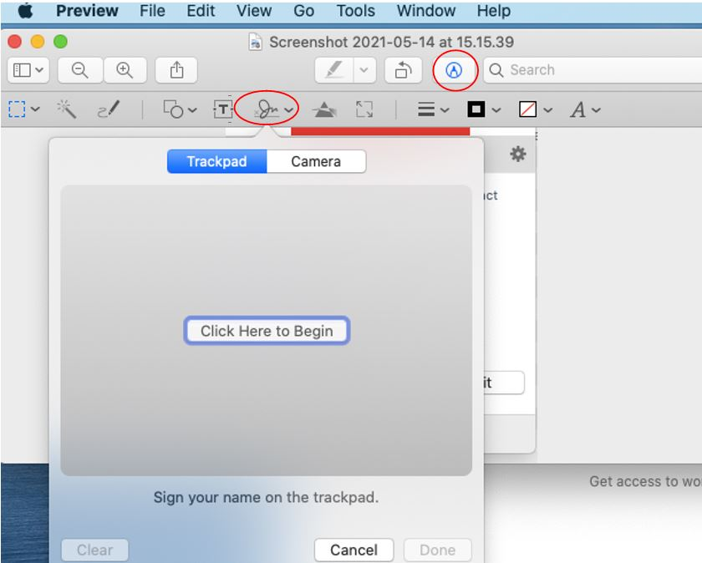

If you’ve ever had to return an official document that’s been sent to you digitally you’ll know the pain of having to add your signature. With macOS, there’s a much better way.

Open the document you need to sign within the **Preview** application. Click the pen icon and then in the menu that appears underneath, click the **signature** icon.

If you're working on a laptop, you'll get the choice of either scrawling your signature on the touchpad (which works surprisingly well) or using your camera to take a photo of your signature.

To use the camera, first make sure you've written your signature on a piece of white paper, then click **Camera** and hold that piece of paper up to the webcam on your Mac. It will capture the signature. Click **Done** when you're happy with it and the Mac will save it.

To sign the document, click the **signature** icon again and then click your signature when it pops up to insert it into the document.

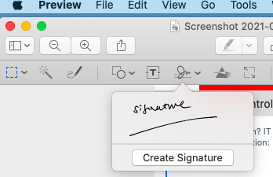

**5. View all special characters**

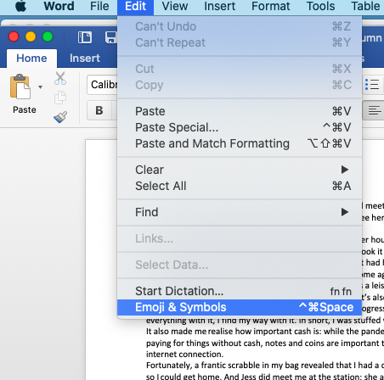

If you want to add emojis to your documents, in the application you're working in, click **Edit** in the menu bar, then **Emoji & Symbols** from the drop-down menu.

This brings up the emoji picker: click in the document where you want to add your emoji, and then click on the emoji you want to add.

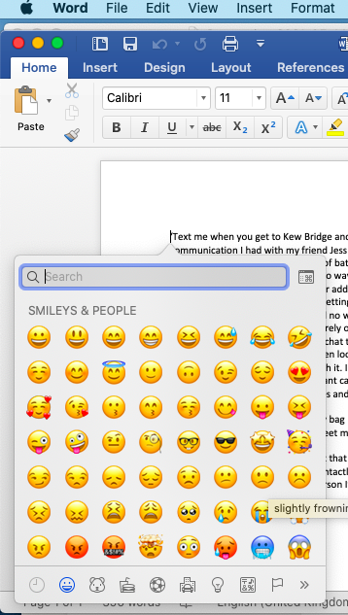

**6. The Mac equivalent of Ctrl + Alt + Delete**

**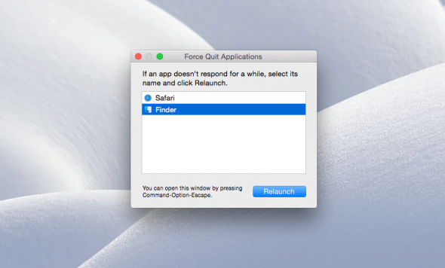**

Macs have their own equivalent of Ctrl + Alt + Delete. Should you find yourself unable to exit a program, hold down the **Cmd + Option** keys and press **Esc**. This will bring up the **Force Quit** dialog box, which will show you all running applications and allow you to forcefully terminate them.

**7. Switch between multiple windows within the same program**

**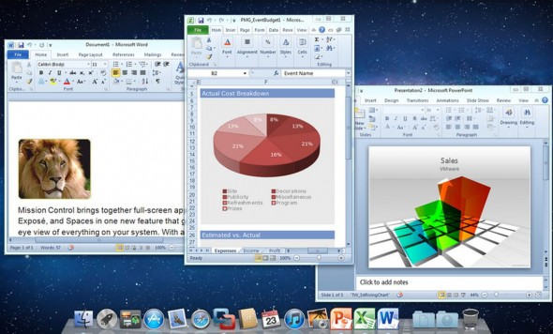**

Using the **Cmd + Tab** keys you can quickly switch between your open programmes. However if you have, say, three Word documents open at once that you wish to switch between, you’ll need a different shortcut.

**Cmd + ~** will instantly switch between multiple windows of the same programme. This will work for any application.

**8. Instantly look up a word in the dictionary or thesaurus**

**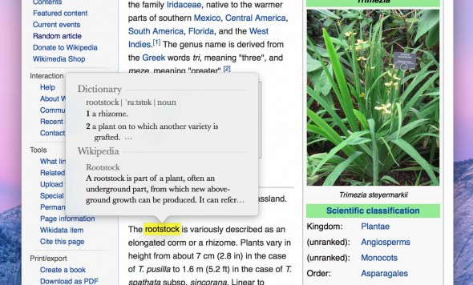**

macOS's reference tool is wonderfully integrated. You can access it from just about anywhere to look up whatever word you like. Select the word you want to learn more about and press the **Cmd + Ctrl + D** keys. Alternatively, if you’re on a MacBook just click it with three fingers on your trackpad.

**9. Start up your Mac silently**

**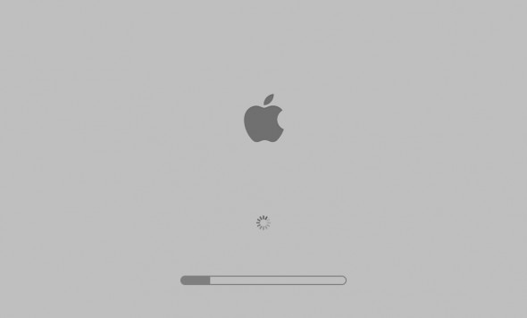**

Even if you’ve never used a Mac before you may well be familiar with the iconic chime it lets off every time it starts up. Unfortunately, that sound is often quite the inconvenience. If you’re somewhere where silence is paramount, such as a class or library, just hold down the **Mute** key at startup.

**10. Convert any sort of unit within Spotlight**

**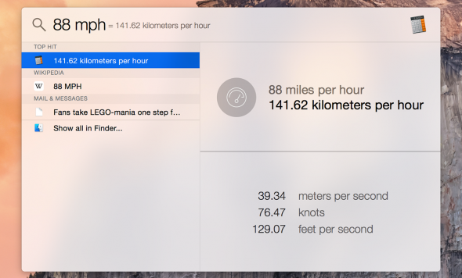**

Spotlight can find things both on your Mac and online, and also solve some basic queries without resorting to opening a new window. One such query is unit conversion. All you need to do is type in the figure you want converted, for example ’57kg’ and it will show you a list of conversions as a search result. This even works with currency, provided you’re connected to the internet.

**11. Trouble finding your cursor? Make it grow**

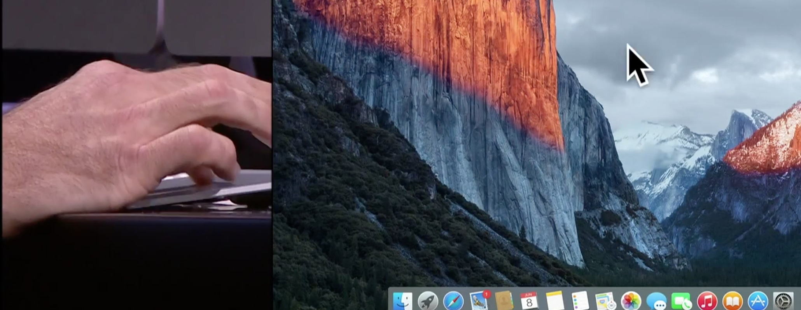

If your Mac is running El Capital or later and you can't find the cursor, either just wiggle your mouse back and forth, or run your finger back and forth on the trackpad if you're using a Macbook. The cursor will balloon in size. Once you’ve located it, simply stop and it will shrink back to normal.

***Want some more help with your Mac? Our friendly tech team can help you with one-to-one support on a range of tech issues. Find out more***[***here***](http://try.which.co.uk/tech-support?_its=JTdCJTIydmlkJTIyJTNBJTIyMTliNjg1YzUtODZiMS00OTQ3LWIxZGQtOTU4NmNkMjlhZTY5JTIyJTJDJTIyc3RhdGUlMjIlM0ElMjJybHR%2BMTY1MjgxODE2NX5sYW5kfjJfNzE1NDlfc2VvXzU2ODY1NmQwZGZjN2QxMzBlMjIyMGU5MDYzMThlYzVlJTIyJTJDJTIyc2l0ZUlkJTIyJTNBODgwNCU3RA%3D%3D)***.***

**12. Merge Finder windows**

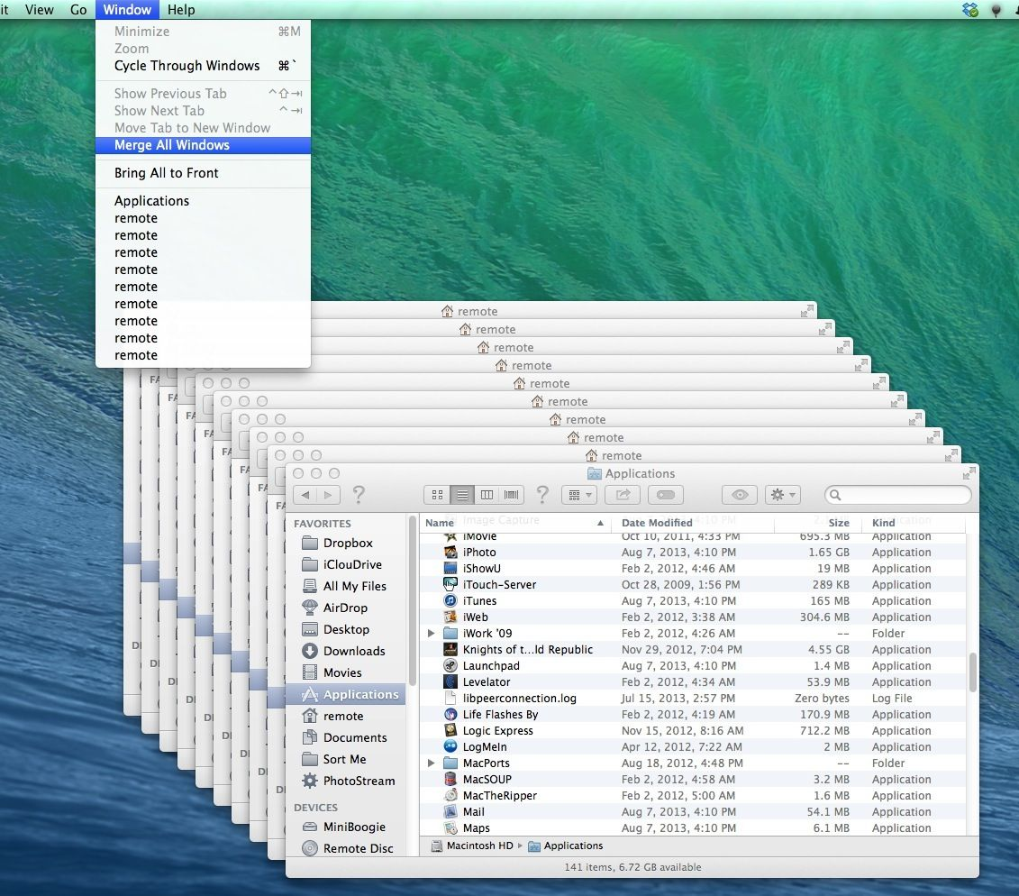

Gone are the days of having to open up a thousand Finder windows when attempting to manage files all around your Mac. If you find your screen filling up with new windows then click on the **Window** option in the menu bar, then click **Merge all windows**. What was previously multiple windows will now appear as neat little tabs within one window.

**13. Disconnect from a wi-fi network without turning off wi-fi**

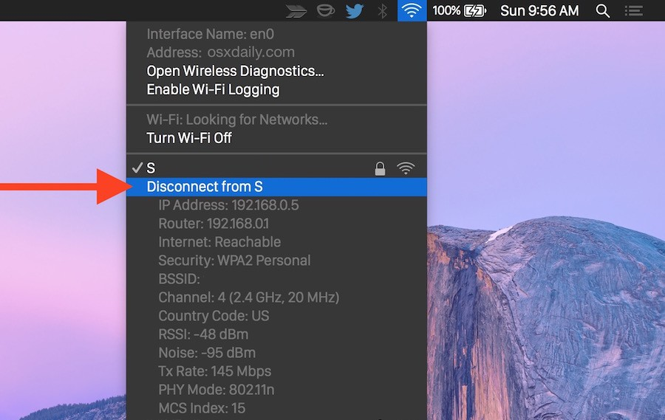

Hold down the **Alt**key and click on the wi-fi icon in your Mac’s menu bar. This will reveal all the options you usually see when clicking on it, plus a larger list of information underneath the name of the network you’re connected to. Directly underneath your network should be an option labelled **Disconnect from [your network name]**. Give it a click and you’ll disconnect – no need to restart your wi-fi.

**14. Record your screen**

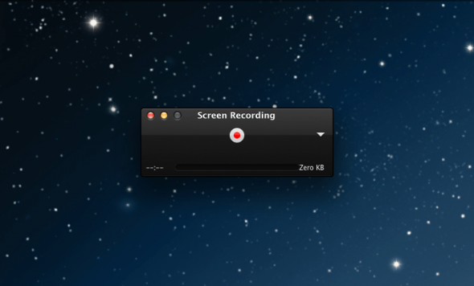

Sometimes a simple screengrab isn’t enough, and you’ll want to capture something animated. To do this you can use a feature built in to **QuickTime**, a program that comes with every Mac as standard. Go to your **Applications** folder (if it’s not already on your shortcuts bar) and open **QuickTime Player**. Click **File > New screen recording.**This will allow you to record the whole of the screen, or just a portion of it. It’s super useful for things like tutorials – it can also capture sound.

**15. Calculate sums in Spotlight**

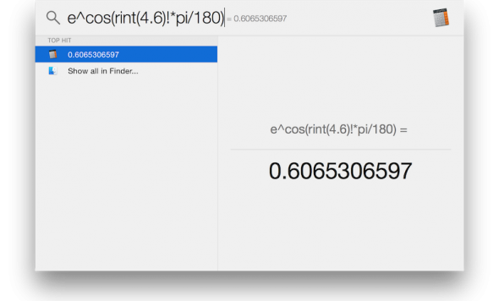

MacOS may have a calculator widget built in, but there’s an even easier way to do quick calculations. Click on the **Spotlight icon** in the top-right corner of your screen, and then go to type in your sum. **+, -, /, \***and **=** correspond to the plus, minus, divide, multiply and equals functions on a conventional calculator. Your result will pop up in the Spotlight box beneath.

**16. Quickly add a foreign or accented character**

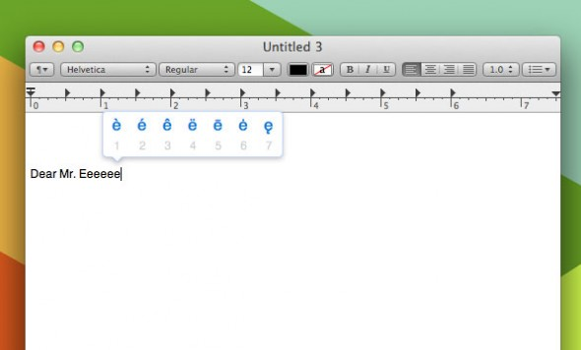

To type a foreign character or character with an accent above it, first find the simple version of the letter you require (e.g. a for á or s for ß) and **hold the key down**. After a brief pause, you’ll be offered a choice of which variant on the letter you want in a little pop-up box above where you’re typing the letter. Select the one you want and it will be inserted into the text field.

**17. No Delete key? No problem**

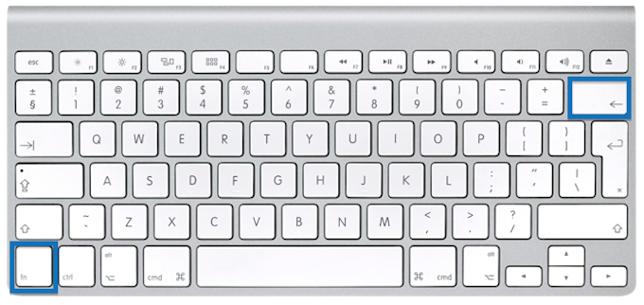

Not every Mac keyboard comes with a Delete key (often stylised as ‘Del’). Instead of jumping to the end of the word you want to erase via backspace every time, just hold down the **Function** key and press **Delete**. This is mainly a problem that will affect MacBook users, but in the event that you’re using a separate keyboard with neither a Delete key or a Function key, holding down **Control** and pressing **D** also works.

**18. Change volume silently**



The volume keys on Apple keyboards are undeniably useful, but there’s one big problem with them – they make noise when you press them, meaning that any attempt to stealthily silence your Mac is immediately thwarted. Unbeknown to many, though, you can actually mute those volume keys – just hold down **Shift** whilst pressing them.

**19. Find a forgotten password for a website or program**

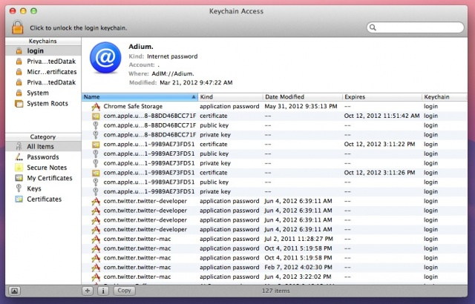

For almost all of the programs on your Mac, as well as many of the websites you visit on it, your login and password details will be stored away, deep within your Mac’s keychain. Don’t worry, they’re encrypted and only accessible locally by the user they apply to.

If you forget one of these passwords, you can actually recover them from within your Mac – as long as you remember the password for your user account.

Open a new **Finder** window and head into your **Applications**. Within this folder should be another folder named **Utilities**. Open up a program within it called **Keychain Access**. You can now see every login stored on your computer. You can sort them by name or type, or you can search for the one you’re looking for using the search tool in the top-right corner.

If you want to view the password for any of the logins, you’ll be prompted for your username and login, just as you would be if you were to install a new program or make security changes to your Mac.

**20. Annotate a PDF or image**

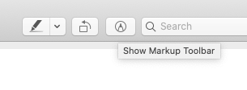

With PDFs – the predominant file type of choice for business communications – it can be very frustrating that you have no way to easily edit them – until now.

Double click on your PDF file and it should open up in **Preview**, the default PDF viewer on (if not you can find it within your **Applications** folder. Once the document is open, click the **pen** icon, which then opens the **markup** menu bar underneath.

Using the tools in that bar you can highlight text and annotate it to your heart's content.

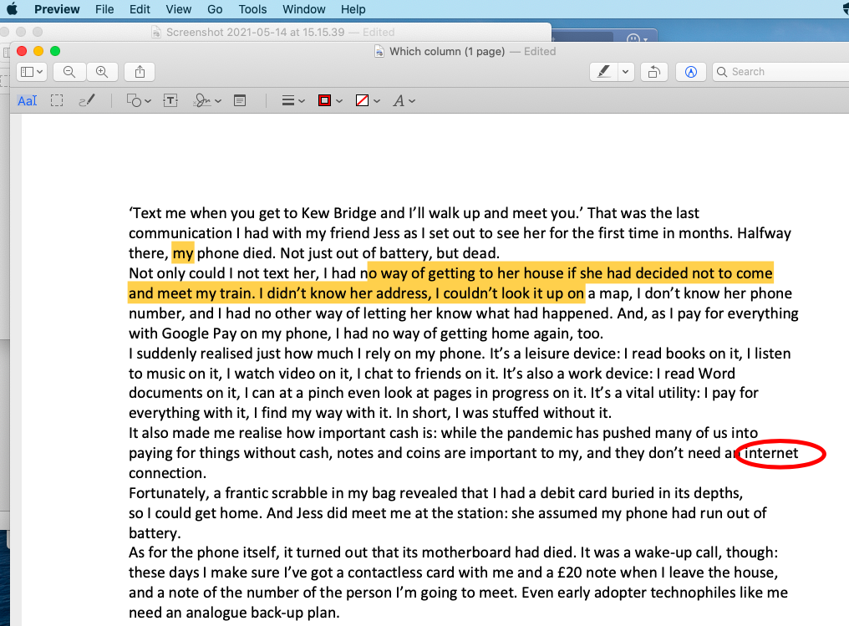

Once you've finished annotating it, you can share the PDF via the **File > Share**option in the Menu bar.

Infromation Source from **WHICH magazine**